CBE Faculty Advising Handbook

2010-11



Revised August 2010 by CBE Dean’s Office

Contents

Faculty AND STUDENT RESPONSIBILITIES in ADVISING 5

Advising Students Throughout their career 7

FRESHMAN YEAR (Freshmen at Towson have a special First Year Experience Advisor - FYE) 7

SOPHOMORE YEAR 8

JUNIOR YEAR 9

SENIOR YEAR 10

THE ADVISING PROCESS 11

Scheduling Process 13

ADVISING THE PBUA or PEBU Student ON COURSE SELECTION GIVEN the STATUS OF THEIR APPLICATION TO THE MAJOR 14

COURSE PREREQUISITES 16

Guide to the Degree Progress Report 17

Advisor’s Quick Guide to Towson’s Online Services 22

whO IS RESPONSIBLE FOR WHAT IN ADVISING? 25

Admission to cbe screened majors 26

Accounting Major 26

BUSINESS ADMINISTRATION AND E-BUSINESS MAJORS 27

Frequently Asked Advising Questions in CBE 29

CATALOG YEAR (a.k.a. Requirement term) 29

TRANSFER 29

Petition for Acceptance of Transfer Credits for CBE Major/Minor 31

Petition to Transfer Credit 31

Petition for a Third Attempt of a Course form 31

Changing a Major or Concentration/Track 31

Terms Used for Grade Point Average 32

Computer Proficiency Examination (CPE) 32

References 33

Academic Achievement Center 33

Academic Advising Center 33

Academic Standards Committee 33

Admissions (Undergraduate) 33

Advanced Placement 33

African-American Cultural Center 34

Alcohol Policy 34

Alumni Relations 34

Athletic Ticket Office 34

Auditing Courses 34

Auxiliary Services Business Office 34

Black Student Union 34

Bursar’s Office 34

Career Center 35

Campus Safety- Escort Program 35

Center for Student Diversity 35

Change of Address, Name 35

Change of Grade/ Incomplete Form 35

Clubs and Organizations 35

Commuter Association of TU 36

Copies Plus Center 36

Counseling Center 36

Credit for Prior Learning 36

Dean’s List 36

Declaring a Major (see “Screened Majors”) 36

Deferred Payment Plan 36

Dining Points 37

Dining Services 37

Disability Support Services 37

Diversity & Equal Opportunity, Office of 37

Drop/Add Period 37

Duplicate Social Security Numbers 37

English Language Center 38

Event and Conference Services 38

Family Educational Rights and Privacy Act of 1974 (Buckley Amendment) 38

Financial Aid Office 38

Fine Arts Box Office 38

Fraternities/Sororities 38

“FX” Grade 38

Good Student Discount Form for Insurance 39

Graduate School 39

Graduation Application 39

Undergraduate Deadlines 39

Graduate Deadlines 39

Health Center 39

Honors 39

Honors College 40

Housing & Residence Life 40

ID Services 40

Insurance Plans (Students) 40

International House 40

International Student Exchange 40

International Student and Scholar Office 40

Internship Program 41

Judicial Affairs 41

Library, Albert S. Cook 41

Meal Plans 41

Military Course Work 41

Minimester 41

National Student Exchange 42

Non-Degree students 42

OneCard 42

Online Registration 42

Online Services 42

Orientation 43

Parking Permits 43

Pass and Audit Grading Options 43

Placement Testing 43

Post Office 43

Readmission to Degree Candidacy 44

Records 44

Refund Policy 44

Registrar 44

Repeat Course Form 44

Repeating Courses 44

Residency 45

Retail/Vending Points 45

ROTC (Reserve Officers Training Corps) 45

SAGE Program (Students Achieve Goals through Education) 45

Satisfactory/Unsatisfactory (S/U) Grading 45

Scholarships 45

Screened Majors 45

Second Bachelors Degree Program 46

Speech-Language-Hearing Center 46

Student Activities, Office of 46

Student Government Association 46

Study Abroad Office 46

Summer Trimester 46

Technology Services, Office of 47

Testing Services Center 47

Transfer Evaluation Services 47

University Police 47

University Store 47

University Union 48

Verification of Enrollment Forms 48

Veterans Affairs 48

Weather and School Closings 48

Withdrawal from Courses 48

Women’s Center 48

Writing Labs and Support Programs 49

CBE Writing Proficiency Program 49

English Writing Lab 49

ESOL Writing Lab 49

Online Writing Support 49

Writing Support Program 49

Websites of interest 50

WHO’S WHO IN THE COLLEGE OF BUSINESS AND ECONOMICS? 51

# Faculty AND STUDENT RESPONSIBILITIES in ADVISING

**Faculty Responsibilities**

As a faculty member, you are responsible for teaching, service, and scholarship. Part of the teaching portion is advising. Students are the reason the CBE is here and it is important to ensure quality advising and mentoring. To be great in your advisor/mentor role, knowledge is the key! Familiarize yourself with the curriculum requirements of the CBE majors and where to find different information based on the catalog years. Make sure your advisee meets the prerequisites for courses to ensure a natural progression in their program plan of study.

It is also important to engage your advisees upon meeting them, learn about them and their career goals, find out their interests; this will take a few minutes but it will help you to understand the student and better advise them. In regards to advising, it is your responsibility to:

* Be available!The number one student complaint is advisor availability.
* Reply to student’s emails and phone calls in a timely manner.
* Be informed about the degree requirements and ask questions. If you are unsure of something, ask your chair.
* If you are meeting with a student for the first time, ask students to map out a course plan for the remaining semesters and bring it with them when you meet next. Check it to make sure the course sequencing meets the prerequisites.
* Assist students in exploring new ideas and directions as they choose general education courses, develop their major and determine professional goals.
* Check the student’s degree progress report. Check for grades, completing required courses, and for any abnormalities (an “A” student receiving a “D” in a course or multiple repeats).
* Ask the student about career goals. A student wishing to be a ballet dancer but expected to get a Business Administration degree from family may want to consider an Entrepreneurship track and Dance minor in hopes of opening up his/her own dance studio.
* Fill out forms with a student, if needed.
* Stay active in the CBE. Read the website ([www.towson.edu/cbe](http://www.towson.edu/cbe)). Stay current about upcoming events, program and curriculum changes.
* Make necessary referrals to other campus and community services as requested or needed.
* Listen to the student!

**Student Responsibilities**

The student advisee is ultimately responsible for all aspects of his/her academic experience, including choosing a major, enrolling in the correct general education and major courses, and being aware of current class status. The student advisee must also be knowledgeable about academic standards, the requirements of the core curriculum under which the student was accepted or changed, major/minor course requirements and prerequisites, and graduation requirements. The purpose of meeting with an advisor is to discuss academic and career goals while examining how best to meet those goals. Specifically, the role of the student in the academic advising process is to:

* Establish and follow a plan for completing core curriculum and major/minor requirements in a timely manner;
* Provide the advisor with academic goals, including internships; extracurricular; and volunteer activities so that the student and the advisor can discuss how these goals fit together to meet the student’s overall aspirations and direction during college and after graduation.
* Be informed of the degree requirements and prepare for advising meetings so that all questions and concerns are answered effectively.
* Maintain a file of advising materials and records.
* Inform the advisor of any changes to the academic plan and determine if those decisions change the course or timeline of the plan.
* Check the degree progress report every semester and notify the advisor of any questions or concerns immediately.
* Apply for graduation by the deadline for the semester in which the student will complete their degree.

# Advising Students Throughout their career

## FRESHMAN YEAR (Freshmen at Towson have a special First Year Experience Advisor - FYE)

**ADVISING OBJECTIVE**:

* The FYE advisor meets each semester with their advisees during their freshman year. When it is time to register for classes, the FYE advisor meets one-on-one with each of their FYE advisees to discuss the student’s academic progress and any other issues of concern and remove the HOLD flag on their account so the student can register.

**SCHEDULING OBJECTIVES:**

* **Take 15 credits a semester.** If a student is taking less than 15 credits, he/she will have to take courses during the summer, or minimester, if he/she wants to graduate in four years (120 credits).
* **Explore different disciplines.** General Education Requirements (GenEds) are designed to help students gain the essential intellectual skills and knowledge that will be important throughout their lives. Suggest that students take some of these courses each semester to balance and complement their major requirements.

**Check prerequisites for courses every semester before registering for classes.**

**TIPS FOR FRESHMAN:**

* Make sure students are not discouraged with some classes such as Accounting or Statistics if they are not strong in math. Many students struggle a little, but you can direct them to resources which may help them make it through these courses and begin taking courses in which they may be stronger.
* If a student is struggling in a class, talk to them about different options. Recommend some possibilities for them, such as tutoring, or different study behaviors. The Academic Achievement Center is a great place to find people who can help students in these subjects.

*-Academic Achievement Center: 410-704-2291, Location: Cook Library, Rm 524*

[*www.towson.edu/aa*c](http://www.towson.edu/aac)

**Tip for ACCounting majors:**

Students should take ACCT 201 and ACCT 202 in their freshman year. By taking these classes early, they can determine whether Accounting is the right area of study for them.

**TIP FOR ACCOUNTING, BUSINESS ADMINISTRATION AND E-BUSINESS MAJORS:**

Ask students to save all their materialsfrom ACCT 201, ACCT 202, ECON 201, ECON 202, ECON 205, ECON 306, FIN 331, LEGL 225, MKTG 341, MNGT 361, MNGT 375, EBTM 337, EBTM 365, and EBTM 311. This will prepare them for the business comprehensive exam given in MNGT 481, Business Strategy and Policy, which is taken in the senior year. This exam is worth 10% of the course grade. Tell them not to stress out too much about this exam. It is a basic overview exam. Information on the Comprehensive Exam is found at <http://www.towson.edu/cbe/Files/programs/undergraduate/ctcbk.pdf>.

**TIP FOR ECONOMICS MAJOR:**

Students should take ECON 201 and 202 in their freshman year. By taking these classes early, they can determine whether ECON is the right area of study. If they find this area does not fit their expectations or interests any further, these courses are also lower level core courses for the Business Administration major and minor, the Accounting major, and the e-Business major, or one of these can be used as a General Education course.

## SOPHOMORE YEAR

**ADVISING OBJECTIVES:**

* Students are no longer assigned to an FYE advisor. As their faculty advisor, you are associated with their major.
* Talk to your advisee about potential internships and career paths. Students may still be undecided on what they want to do, so talking to them openly about their options may help them determine which major is best for them.
* Talk about the benefits of joining a student organization and studying abroad.

**SCHEDULING OBJECTIVES:**

* Make sure that your advisee attempts to complete all lower level core classes this year.
* Review the requirements for admission to the screened majors. Remind students of the importance of attaining the minimum QPA, registering for the Computer Proficiency Exam and submitting the application for admission to the major by the deadline (October 1 and March 1).
* Suggest the Gen Ed Category I.D. advanced writing course this year. For business majors, we recommend ENGL 317 – Writing for Business and Industry. However, any GenEd I.D course is acceptable. This course will provide a strong foundation of writing skills for the upper-level major classes. Also, the GenEd I.D.is a prerequisite/ co-requisite for the BUSX 301 – Business Cornerstone that Accounting, Business Administration and e-Business majors need to complete.

**TIPS FOR SOPHOMORES:**

* All courses required for the major or minor must be passed with a “C” (2.0) or better! If a grade lower than a “C” is achieved, the course will need to be repeated. For admission to the major, *the CBE allows no more than two of the lower level core courses to be repeated, of which no more than one course may be repeated twice* (only one *third attempt* of a course). Students that transfer in a grade of a “C-“ must repeat the course to get a “C” or better.
* Talk to students about getting involved. College is not just about going to class. There are several student organizations within the CBE for all disciplines. From savvy marketing students in the American Marketing Association to financial gurus in the Towson University Investors Group, there are plenty of opportunities to expand their book knowledge and enhance their real world experiences. Visit the CBE student organizations website for a listing of all the clubs and how to join at <http://www.towson.edu/cbe/student_resources/student_orgs.asp> or visit the University’s student organization web site for a complete list of offerings on campus at <http://wwwnew.towson.edu/studentactivities/StudentOrganizations/organizationdirectory.asp>
* This is the best year to plan a study abroad program! Many lower-level core courses and General Education requirements can be taken through these programs for credit at Towson. Programs take place in many countries, including China, Australia, and Italy. Visit the Study Abroad website for more information:

<http://wwwnew.towson.edu/studyabroad/>

* Accounting, Business Administration and e-Business are screened majors. In order to move further in the major, students must complete the appropriate application for their major, finish all lower-level core courses, and meet the minimum QPA. Each major has different admission requirements that vary by catalog year, so it is important to check with the appropriate catalog to verify the requirements.
  + To calculate a QPA for your lower-level CBE courses for admission to the BUAD and EBUS majors, visit the following website: <http://www.towson.edu/cbe/student_resources/advising/qpa.asp>
  + Application forms for the screened majors are available at <http://www.towson.edu/cbe/student_resources/advising/intomajor.asp>

**TIPS FOR SCREENED MAJORS:**

If a student is in a screened major (ACCT, BUAD or EBUS), it is recommended that they apply to the major in the semester that they are completing the lower-level core courses. There are deadlines to apply, October 1st for spring admission and March 1st for summer and fall admission. Students only need to apply once. As an advisor, you should know their status prior to them applying and can be able to help them make the next steps.

You can check whether a student has been accepted into the major by logging onto Towson Online Services, opening the unofficial transcript, and scrolling down to your most recent semester. If the student is still listed as Pre-Business, Pre-Accounting or Pre-e-Business, ask if the student has submitted the application. If the student has applied, he/she would have received an email noting their admission status as pending, denied, or ineligible.

## JUNIOR YEAR

**ADVISING OBJECTIVES:**

* Some majors have concentrations or tracks. Once students have taken some upper-level courses, choosing a concentration or track will be a lot easier. Talk to your advisee to help them decide what area of study to choose. In order to graduate on time, students should decide what their concentration or track is no later than the registration for second semester classes in their junior year.

**SCHEDULING OBJECTIVE:**

* Work with your advisee to update his/her 4 year plan to ensure a timely graduation. Note there are 4 year plans on our website for each major.

Accounting: <http://www.towson.edu/accounting/acct_major/sequence.asp>

Business Administration: <http://www.towson.edu/cbe/buad/sequence.asp>

e-Business: <http://www.towson.edu/cbe/ebusiness/undergrad/suggested-course-sequence-ebus.asp>

Economics: Not on website

* When planning the sequence of upper-level CBE courses, make sure to adhere to the prerequisite constraints for those courses, especially when planning the concentration or track course sequence. The Online Prerequisite Checking Matrix can be downloaded each semester from [www.towson.edu/cbe/student_resources/advising](http://www.towson.edu/cbe/student_resources/advising).

**TIPS FOR JUNIORS**:

* Internships offer an excellent opportunity to explore job options, gain practical experience, learn new skills, and network with professionals. How do students find an internship? Students can use the available resources at the Career Center and contacts from networking events hosted by the CBE. Also, a CBE Internship Newsletter is sent out monthly to all CBE juniors’ and seniors’ email accounts from our Director of Professional Experience for CBE. Students can also use their own resources to acquire an internship. If you know someone who is looking for an intern, direct them to the Director of Professional Experience. They will be able to assist your contact in filling the position.
* Students who are required to take the Professional Experience course (BUSX 460) must have an approved internship prior to registering for the course. Students should review the requirements and procedures on the following website to insure no delay in completing the course:
  + <http://www.towson.edu/cbe/intern_career/>

## SENIOR YEAR

**ADVISING OBJECTIVE:**

* Before registering for the final semester, students should meet with you to review all graduation requirements. Continue monitoring the courses on the Degree Progress Report online.
* Remind students to **APPLY FOR GRADUATION!** This can be done by going to Towson Online Services. Click on Self Service, Student Center, under the heading Academics, click on the drop down and select Apply for Graduation and click the arrow (go). It’s that simple! The deadlines to apply for graduation are:
  + Spring - January 10 (online application deadline)
  + Summer - July 10 (online application deadline)
  + Fall - August 21 (online application deadline)

**SCHEDULING OBJECTIVE:**

* It is very important to register on time. If students delay past their registration date, the final courses they need may be full.

**IMPORTANT NOTES:**

* Make sure a “C” or better in CBE courses is earned. Not passing a course will delay graduation.
* If the student is a transfer, make sure that all classes properly transferred and the student has all petitions together as proof of completion of all courses.

**GRADUATION CHECK REQUIREMENTS REMINDER:**

* 120 total credits completed
* Completed all Gen Ed categories in the catalog year
* Completed all lower-level and upper-level courses in the catalog year
* Completed all concentration courses in the catalog year
* Apply for graduation on time
* 2.0 QPA

After applying for graduation, the student will be sent an information packet about graduation procedures, including how to order the cap and gown, to the local address listed on PeopleSoft. Students will receive their diploma after graduation, which will be mailed to their permanent address.

# THE ADVISING PROCESS

***A. Checklist for Faculty Advisors – What do you need to get the job done***

**Preparation for the Advising Appointment:**

**References to Have Ready:**

1. Copies of current and past TU Catalogs
2. TU Faculty Advising Handbook

**Resources to Have Ready**:

1. Access to PeopleSoft as an advising tool
2. Student’s folder (A student folder for each advisee is a good idea so that you have a copy of their advising form at all times so that it can be updated. Departments also have student files that contains University forms and transfer evaluations, if applicable. You should make a copy of the transfer evaluation form for your own file on the advisee)

**Forms to Have Ready:**

1. Advising form for each catalog and major can be found at <http://www.towson.edu/cbe/student_resources/advising/>

**Processes to Know About**

1. Acceptance of Transfer Credits for Major/Minor
2. Change of catalog
3. Transfer of new course work after matriculating at TU
4. Change of major/minor
5. Third Attempt of a Course
6. Application to the screened major

|  |
| --- |
| **Forms:**   * Advising forms by catalog year- <http://www.towson.edu/cbe/student_resources/advising/forms.asp> * Petition for Acceptance of Transfer Credits for Major/Minor (Student Academic Services) * Catalog Selection Petition- <http://www.towson.edu/registrar/Forms/> * Petition to Transfer New Course Work to TU (to take at another institution)- <http://www.towson.edu/registrar/Forms/> * Change of Major/Minor (Declaration of Major)- <http://www.towson.edu/registrar/Forms/> * Petition for Third Attempt of a Course <http://www.towson.edu/registrar/forms/documents/Third_Attempt_form.pdf> * Application for admission to the ACCT, BUAD or EBUS major- <http://www.towson.edu/cbe/student_resources/advising/intomajor.asp> |

**Information you may need to get from your department:**

1. For new transfer students who forget to bring their TUCARES advising form, you may need to request the advising form with an evaluation of transfer credits from the student’s file.

**Questions?**

Ask your department chair.

***B. Starting the Process***

Each semester send an e-mail to your advisees alerting them to your office hours and that you are available at other times if they make an appointment. The e-mail might read:

*Greetings All,*

*Welcome to the new semester! I wanted to let you know my office hours for this semester should you need to see me for any reason. They are MWF from 9-11am. If this is not convenient, please don’t hesitate to contact me for an appointment at another time. As the semester gets in full swing, don’t forget to pencil me in your calendar so we can go over your academic plans for next semester and talk about your academic progress, career goals, graduate school or whatever is on your mind. I am here to help.*

During Intentional Advising Weeks (typically two weeks before registration begins), faculty hold extra office hours to accommodate students. Sending a follow up e-mail alerting them to the signup sheet on your door is advisable. Again the e-mail might read:

*Greetings All,*

*The College of Business & Economics hosts Intentional Advising Weeks during the following time frame __________. During this time, I am holding extra office hours to assist you in discussing your academic progress and check your planned schedule for next semester. At this time, I will also remove the HOLD on your account so that you may register at your assigned time. I have placed a signup sheet on my office door, ST ____. Please stop by to sign up for a time slot.*

*If you fail to make an appointment or show up for the scheduled time, I cannot promise that I will be able to accommodate you for another time prior to your assigned registration date.*

That should provide them with the incentive to show up. ☺

***C. Beginning the Conversation***

When you meet your advisee for the first time, take a few minutes to get to know them. Here are some suggested questions that may be helpful.

* Tell me about yourself.
* What do you hope to do with your life?
* What kind of extracurricular activities are you interested in?
* Have you had any difficulty in adjusting to the university?
* How can I help you the most?
* Policies, course scheduling, career information, academic/personal problems?
* What major or majors (concentration) are you considering?
* Why are you considering this major?
* Are there any special situations that I need to consider in planning – job or family responsibilities?
* What questions do you have about the university, major, course requirements, scheduling?
* Are you aware of the resources available to you? (Tutoring, counseling, career planning, study abroad, Honors College).

Scheduling Process

**Check Academic Progress**

* If GPA is less than 2.0, ask student to repeat FX, F, D-, D, and D+ grades.
* If the grade of FX, F, D-, D, or D+ is in a MAJOR course, student must repeat for a “C” or better.
* If a course needs to be attempted more than twice, have student fill out the “Third Attempt of a Course” form (found at [www.towson.edu/registrar/forms](http://www.towson.edu/registrar/forms)) and submit to Academic Standards.

**Check Credit towards Graduation**

* Minimum of 120 credits **Excludes repeated courses or duplicated transfer courses**
* Minimum of 32 upper-level credits (300 or 400 level)

**Plan Courses for Next Semester**

* Pay special attention to course prerequisites. (Online Prerequisite Checking Matrix located at <http://www.towson.edu/cbe/Files/students/CBE_Online_Prerequisite_Checking.pdf>)
* Discuss his/her interests with student.
* Remove Advising Hold

**Update the student’s advising form.   
If new one is needed, click on**

<http://www.towson.edu/cbe/student_resources/advising/forms.asp>

**Evaluate Completion of University Requirements: (GenEds)**



**GenEd Rules:**

* Gen Ed II. A 8 to 10 units. At least one must be a lab course.
* Gen Ed II.B.1: Must be different discipline than II. C.1.
* Gen Ed II. C.2: 2 courses in 2 different disciplines.

**Evaluate Completion of Major Requirements**

* Must have a grade of “C” or higher in all courses for the major
* If a “C-“, “D-“, “D”, or “D+“ grade is earned or transferred then the course MUST BE REPEATED
* If a transfer course might be equivalent to a major requirement, PETITION the course with the department which offers the course at Towson (form located in ST 301)
* GenEds may also fulfill a major requirement, e.g., ECON201 or 202.

**Access Student’s Degree Progress Report Transcript in PeopleSoft**

Top Section of the Report

**Academic Program History and Basis of Admission**

**Determine the Student’s Major and Catalog Year**

# ADVISING THE PBUA or PEBU Student ON COURSE SELECTION GIVEN the STATUS OF THEIR APPLICATION TO THE MAJOR

It is the student’s responsibility to verify that he/she has met the prerequisites to a course prior to enrolling. See the Online Prerequisite Checking Matrix: <http://wwwnew.towson.edu/cbe/Files/students/CBE_Online_Prerequisite_Checking.pdf>. Students who enroll in an upper-level CBE course for which they are not eligible will be administratively disenrolled from the course.

|  |  |
| --- | --- |
| **Application Status** | **You may register for:** |
| **Accepted** | * CBE Upper-Level courses provided you have all prerequisites, including class rank.   EXCEPTION to register for "Junior” courses: If your total units plus the units you are enrolled in this term are between 48 to 59.5 units, the student should go to the department that offers the course to receive a "Special Permission" code. |
| **Pending** | * The BUAD Upper-Level Core courses (BUSX 301, EBTM 337, EBTM 311, ECON 306, FIN 331, MKTG 341, and MNGT 361) provided the student has all prerequisites, including class rank.   EXCEPTION to register for "Junior” courses: If the total units plus the units enrolled in this term are between 48 to 59.5 units, go to the department that offers the course to receive the "Special Permission" code.  EXCEPTION to register in a course other than the BUAD U/L Core courses listed above. Submit a “Petition for Exception to Register for an Upper-Level CBE Course” form, available in CBE Student Academic Services, Stephens Hall 301. |
| **Denied** | * NO CBE upper-level courses. (Not eligible) * To improve the QPA of the Lower Level Core courses for admission to the major, repeat one or two Lower-Level Core course(s).   **Note:** No more than TWO courses in the lower level core may be repeated, of which NO more than ONE course may be repeated TWICE. A grade of “W” does not count as an attempt. Before making a third attempt of a course, approval must be received from the Academic Standards Committee. Submit a Third Attempt of a Course Petition available from <http://www.towson.edu/registrar/Forms/documents/Third_Attempt_form.pdf>.   * To improve the TU GPA, repeat any course where the student earned less than a “C.” * Any General Education Requirements not completed. |
| **Ineligible** | * NO CBE upper-level courses. (Not eligible.) * The Lower-Level Core course(s) or Computer Proficiency Exam (CPE) not completed. * Or if complete, repeat of one or two Lower-Level Core course(s) to improve the QPA of the Lower Level Core courses to meet the 2.70 QPA admission requirement.   **Note:** No more than TWO courses may be repeated, of which NO more than ONE course may be repeated TWICE. A grade of “W” does not count as an attempt. Before making a third attempt of a course, approval must be received from Academic Standards. Submit a Third Attempt of a Course Petition available from <http://www.towson.edu/registrar/Forms/documents/Third_Attempt_form.pdf>.   * Any course where the student earned less than a “C”, to improve the TU GPA to a 2.00. * Any General Education Requirements not completed. |

**One Semester Exemption:** An exception to take an upper-level CBE course concurrent with repeating or taking a lower-level BUAD Core course will be considered if the student has at least a 2.60 major QPA in the lower level core courses and a 3.00 TU GPA. Submit a “Petition for Exception to Register for Upper-Level CBE Course” available from CBE Student Academic Services in Stephens Hall 301.

# COURSE PREREQUISITES

|  |  |  |  |  |
| --- | --- | --- | --- | --- |
| PREREQUISITES for Upper-Level CBE CORE Courses | | | | |
| Open to Eligible PBUA- pending category | |  | OPEN to ACCT, EBUS and BUAD majors ONLY | |
| **Course** | **Prerequisites** | **Course** | **Prerequisites** |
| BUSX 301 | * ACCT 201/211 * ACCT 202/212 * ECON 201/203 * ECON 202/204 * ECON 205 or MATH 231 * LEGL 225 | BUSX 460 *(special permit)* | * BUSX 301 * FIN 331 * MKTG 341 * MNGT 361 * Six additional credits of CBE courses |
| EBTM 311 | * BUSX 301 * EBTM/MNGT 337- may be taken concurrently |
| **ECON 306** | * ECON 201/203 * ECON 202/204 * ECON 205 or MATH231/233 | EBTM 365 | * ECON 205 or MATH 231 |
| **FIN 331** | * ACCT 201/211 * ACCT 202/212 * ECON 201/203 * ECON 202/204 * ECON 205 or MATH 231/233 | MNGT 375 | * BUSX 301- may be taken concurrently |
| MNGT 482 | * MNGT 361 * Senior major standing |
| **MKTG 341/ 342** |  | MNGT 481 | * FIN 331 * MNGT 361 * MKTG 341/ 342 * EBTM 365 * BUSX 301 * Senior major standing |
| **MNGT 361** |  |
| **EBTM 337** | * COSC 111/115 or CIS 115 or passed CPE |

Additional prerequisites for CBE courses can be found at <http://www.towson.edu/cbe/Files/students/CBE_Online_Prerequisite_Checking.pdf>.

# Guide to the Degree Progress Report

The Degree Progress Report contains two parts; the “Academic Transcript” and the “Academic Advisement Report”, which is an audit of academic work. With it, you can quickly and easily assess a student’s

* General Education requirements (“GenEds”)
* Credits earned towards graduation
* Major and Minor coursework

**To get started:**

* In the web browser, go to <http://inside.towson.edu>
* On the right hand side, click on “Faculty/Staff/Student/HR/Payroll Entry to Peoplesoft”

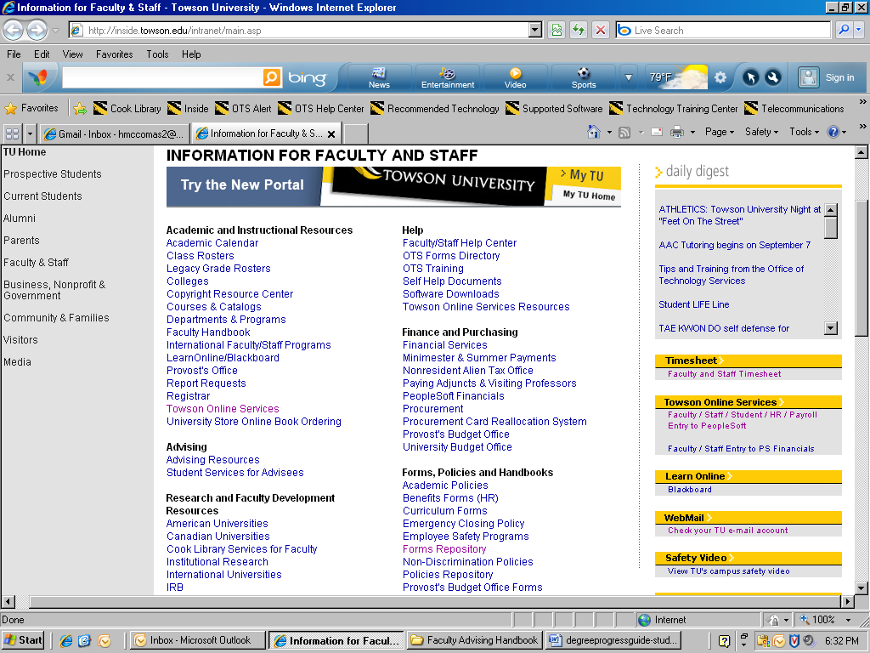

* Log in to your Towson Online Services Account

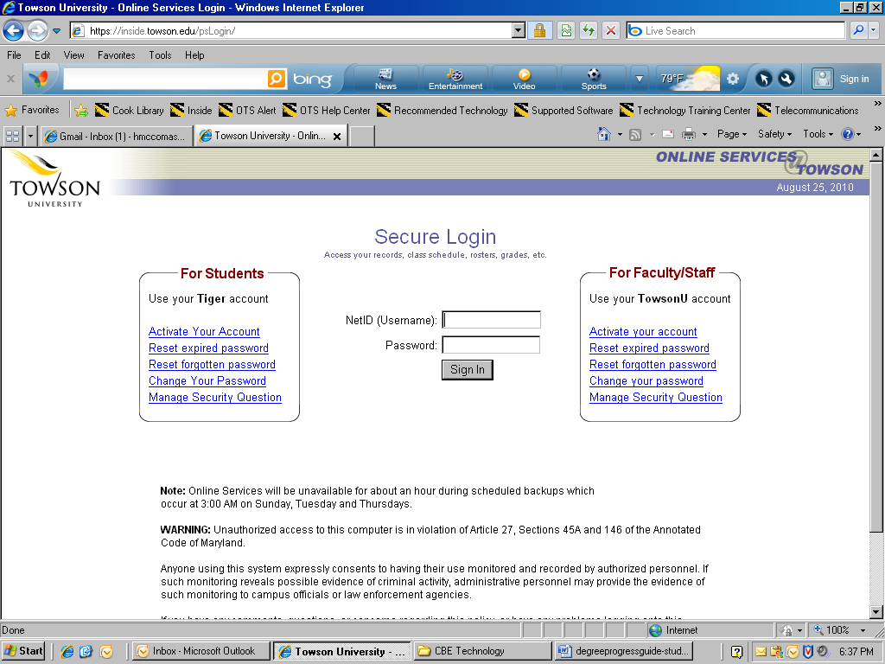

**To view the Degree Progress Report:**

* Click on Self Service, then “My Advisees”

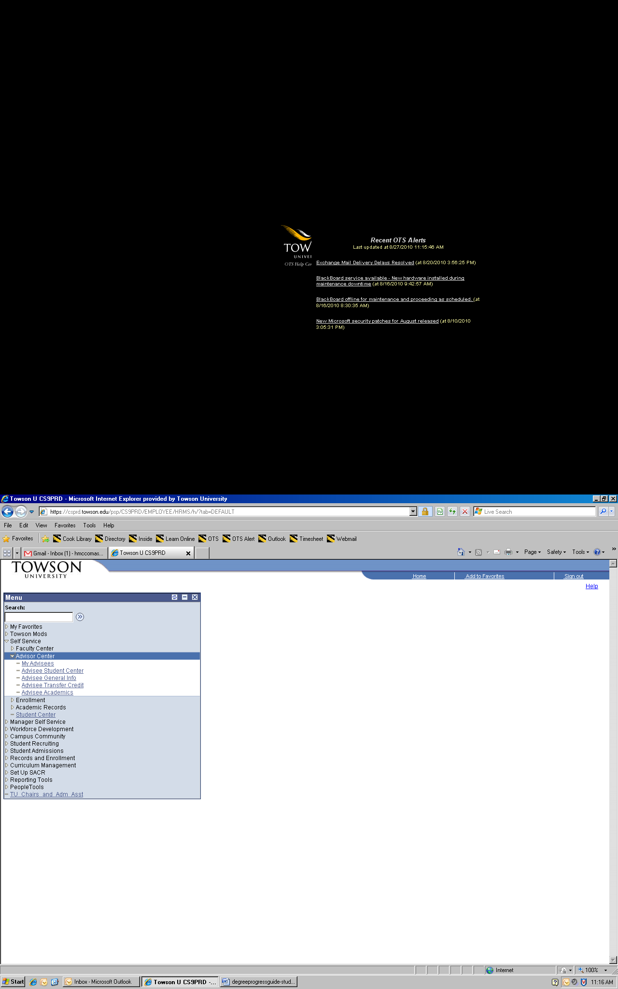

* Click on the student you wish to view

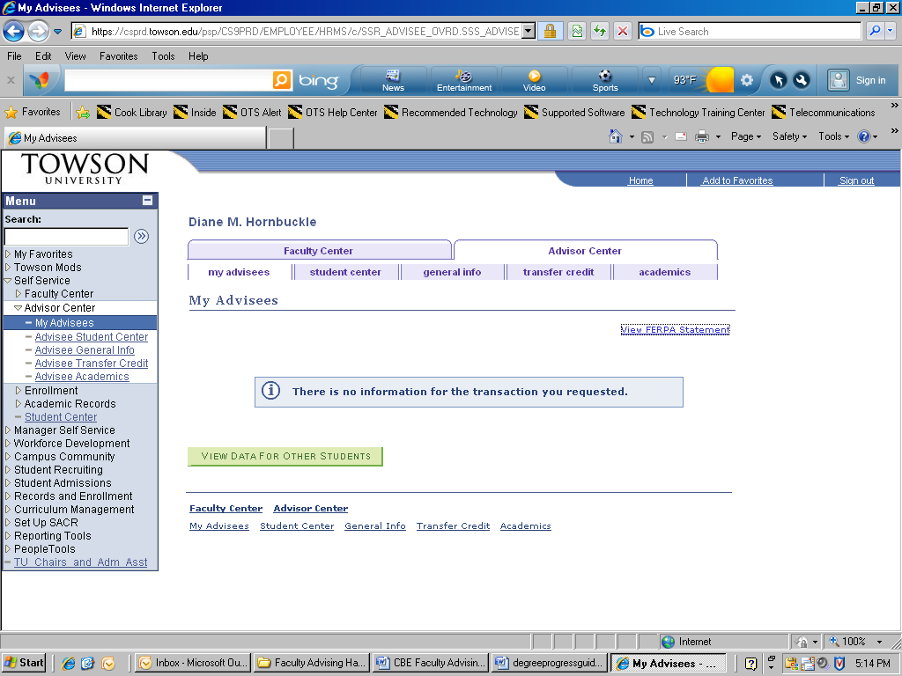

* You will see the page to view the Degree Progress Report.

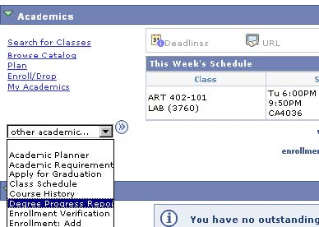

* Choose “Towson University” for the Academic Institution and “*1. Degree Progress Report*” for the *Report Type*. Then select “go.” This may take a while to process.

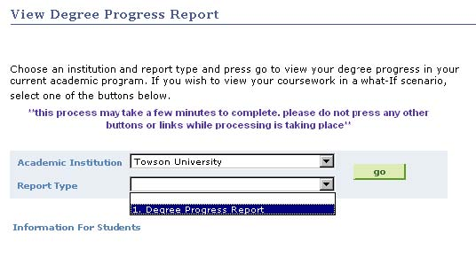

**What information is contained in the Degree Progress Report? The report contains a student’s:**

* Upper-Level Credits - Upper-level credits are those that are equivalent to 300 level or above.
* Progress on each GenEd category - There are twelve different categories.
* Overall credits towards graduation - At least 120 are required for graduation.
* Overall GPA - At least a 2.0 GPA is required for graduation.
* Major and minor course evaluation - Courses evaluated for the completion of your major or minor.

**Important!**

This report evaluates the courses the student is currently taking, and assumes successful completion.

**Interpreting the Report**

A requirement that is NOT satisfied is listed in **bold** and **red:**

**Example 1: GenEd not satisfied**

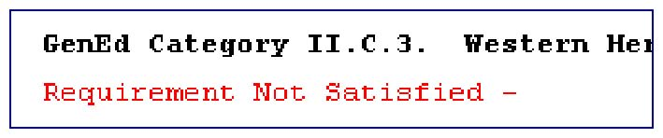

**Example 2: Required number of credits not satisfied**

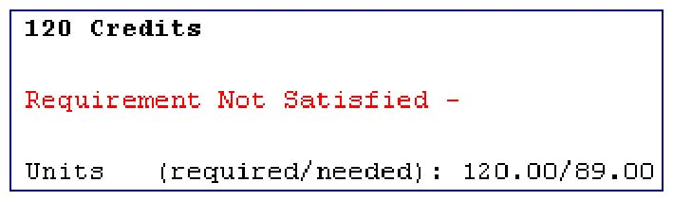

A requirement that IS satisfied is listed in plain text, usually followed by detail of what course satisfied the requirement:

**Example 3: Transferred MATH231 course satisfies requirement**

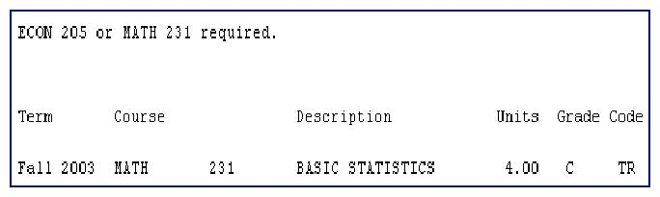

**Cautions**

Great care is being taken to create both accurate and complete reports of a student’s academic progress; however, it is possible that the reports may contain errors or omissions.

If the student has a question concerning his/her degree progress report, please ask them to contact Academic Advising at 410-704-2472 for General Education requirements and the major department for major requirements.

**Transfer Credits**

If a student has completed a transfer course that:

* is equivalent to a TU General Education course; it is identified on the degree progress report as such, together with the credits earned at the transfer institution.
* has no direct TU equivalent, it is evaluated individually. If it satisfies a General Education course, then an alternate alpha and numeric code designates the General Education category. It is posted with the General Education “category” and a lower-level designation, e.g., IB 10T course. The credits and grade are also posted.

**What if a student wants to change his major?**

The degree progress report also lets you see the progress with a different degree (BS, BA, etc.), major, or catalog year. This feature is helpful for pre-majors to see the courses required once admitted into the major.

Choose “*Towson University*” for the Academic Institution and *1. Degree Progress Report* for *Report Type*.

Scroll down, and you will see the *Quick What-If* and *Course List What-If* buttons.

**Quick What-If**

Click on *Quick What-If*. You will see the fields below. Fill in career, program, plan, and/or subplan you would like to override and the requirement term (i.e. catalog year). If you are filling in the Plan override (major), you will also need to fill in the Career and Program override fields.

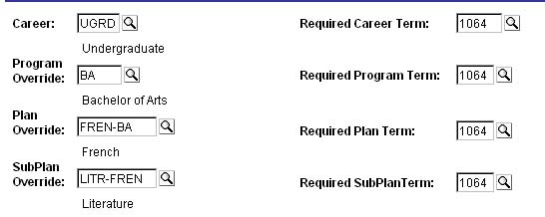

Click *OK*. The degree progress report will display your “new” evaluation.

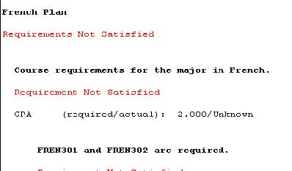

**Not sure if a particular course will fulfill a General Education or major requirement?**

Click on *Course List What-If*. Type in the subject of the class you are looking for, and click *Search*.

All of the courses for the subject you picked will be displayed. Click on *View all*to display all courses.

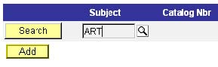

Scroll down to find the course you are looking for, and click on the check box for that course.

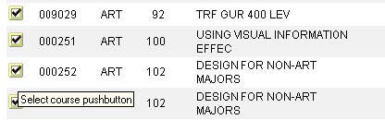

The course you would like to take will now be displayed



Click *OK*. The course you would like to take will be displayed under the requirement it would satisfy on the degree progress report.

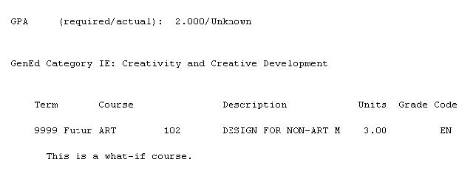

Advisor’s Quick Guide to Towson’s Online Serviceslogo**(9.0)**



|  |  |
| --- | --- |
| **Task** | **Procedure** |
| **Login** | Type into the browser: **http://inside.towson.edu/,** Click **Towson Online Services,** Type your **Username** and **Password**, Click **Sign In.** |
| **Access Your Assigned Advisees** | **Click** **Self Service, View My Advisees** to access your “Advisee Roster,” which displays all of your assigned advisees (enrolled and not enrolled this term).On the line with the student’s name, click **View Student Details.** |
| **Access Information for a Drop/In Advisee** | **Click** **Self Service, View My Advisees**. **Click** the **VIEW DATA FOR OTHER STUDENTS** button at the bottom of the page. Enter the student’s TU ID in the ID field. Click **Search** button. If ID is unknown, type in the student’s Last and First name in the appropriate box. Click **Search.** In **Search Results,** click on the **Name** of the student. |
| **Email Your Assigned Advisee(s)** | **In Advisee Roster, click** on **notify all advisees** button at bottom of page to Send Notification (email) to all your advisees. Type your Message and then click on **SEND NOTIFICATION** button. **Click** on **Return to Advisee Roster**  button. To email selected assigned advisee(s), click the box in the **Notify** column for each student. **Click** on **notify selected advisees** button. |
| **Download Advisee List to Excel** | In View My Advisees link, **Click** the Download Button **Download** .Click on Open or Save file. Suggest sort by Status to see only Enrolled. (To avoid Pop-Up Blockers, press **Ctrl** + **F10**) |
| **View the**  **Student Center information for the Advisee** | |  |  | | --- | --- | | **View:** | **To Find:** | | **Academics** | Student Class Schedule, My Planner, Degree Progress Report. In “other academic...” box, click on Go to access Academic Requirements, Course History, Grades, and Transcript: View Unofficial, Transfer Credit Report. | | **Week’s Schedule** | Day, time and location for each enrolled Class for the current week | | **Personal Information** | Contact Information: Permanent Address, Local Address, Phone and Campus (email). | | **Holds** | Intentional Advising Program (IAP), Bursar, Academic Advising, etc. | | **To Do List** | Due Dates for Financial Aid, etc | | **Enrollment Dates** | Date student is eligible to register for classes by term. | | **Advisor** | Advisor’s name and email address. Also, Program Major is in “details”. | |
| **Access information in Academics**  **in Student Center** | |  |  | | --- | --- | | **Click on:** | **To Access:** | | **Student Class Schedule** (detailed) | Select Term, click on Continue for student’s current or future class schedule by term. Weekly calendar view is available. Click CANCEL to exit. | | **My Planner** | The student-generated plan of courses for each term. | | **Degree Progress**  *(details below)* | Academic Advising transcript and report showing student’s progress in GenEd and major/minor requirements. Used for graduation clearance. | | **Academic Requirements** | A display of the GenEd and Major requirements. Completed requirements are collapsed and unsatisfied requirements are expanded. | | **Course History** | A sorted list of all courses, including course name, grade, term and status. | | **Grades** | Class Grades by term. Also, Term Statistics, which include cumulative GPA and Grade Points, and Graded units taken towards GPA and not for GPA. | | **Transcript: View Unofficial** | Academic record of classes, grades, etc. by term. Select Report Type -“**Unofficial Transcript”**, then click “**Go”**. | | **Transfer Credit Report** | Transfer Courses accepted by TU and their Towson course equivalent sorted by each transfer institution. Click on "**View All**" for all institutions. | |
| **View Advisee’s Degree Progress Report:** | 1. After selecting the advisee’s ID, **click** **View Student Details** on the line with the student’s name. 2. In **Student Center** click on **Degree Progress Report.** In drop-down menu for **Academic Institution, select Towson University** and **1. Degree Progress Report in Report Type** 3. Click "**Go.” “*Processing*”** signals retrieval of student’s report. |
| **Print a Copy of a Report** | Select **File** > **Print** from your browser menu.  In the print window, click the **Print** button, then the **OK** button. |
| **Task** | **Procedure** |
| **Find Student’s Information on the Degree Progress Report** | Program and major: top of report underAcademic Program History.  Catalog Year: under Basis of Admission section.  Total Credits and Cum GPA: end of Undergraduate Record section.  GenEd not completed: in Academic Advisement Report section, indicated by BOLD ”Requirement Not Satisfied” |
| **Understand the meaning of the symbols** | This Negative Service Indicators Negative Service Indicator signifies a Registration HOLD for advising, etc. Other icons are:  Positive Service Indicators Positive Service Indicator: Athlete, Honors College, etc.  Academic Information Academic Information: BS/BA, Major, Concentration/Track, etc.  FERPA FERPA Restrictions Apply: No Data Releasable |
| **Remove the Academic Advising Hold** | On the Student Center page, click on the Hold Negative Service Indicators icon. Click on [**ADV**](javascript:submitAction_win0(document.win0,'SRVC_IND_CODE$0');) code for Academic Advising Hold, Intentional Advising Program (IAP). Click the button. Click [Save component and return](javascript:submitAction_main0(document.main0,%20'#ICSave');) for “Are you sure you want to release this Service Indicator?”  Release |
| **View Schedule of Classes and find Open GenEds** | **Click** **Self Service, Faculty Center,** and then **Class Search** tab on top of page. Check **Term**.  Enter **Subject** and **course number** (if known), then **click SEARCH.**  To see all courses offered, **uncheck Show Open Classes Only.**  To find Open Sections of a GenEd, Click on “**Advanced Search Criteria.**” Click the drop-down arrow and select a “**GenEd Category.”** Click **Search.** |
| **View Course Details and Prerequisites** | In **Class Search**, **Search for Classes** panel (see above), select course by clicking on [Expand / Collapse](javascript:submitAction_win0(document.win0,'DERIVED_CLSRCH_SSR_EXPAND_COLLAP2$98$$0');) next to course. Click on **Section**: Discipline, # , Section # ,(class #) |
| **Open a New Browser Window** | On browser menu, click on **File, New, Window** hyperlink to open another transaction. Toggle between windows: press Alt +Tab. |
| **Set Preferences for Academic Career and Term** | On Menu, click **Set Up SACR, User Defaults.** Under User Defaults 1 tab, For Academic Career, select **“UGRD**” for Undergraduate; for Term, enter **Term** (e.g., 1092). Click **Save.** |
| **Logoff** | Click **Sign Out** in top right corner and close the browser window. |

|  |  |
| --- | --- |
| **PeopleSoft Terminology** | |
| **Academic Institution**  = TOWSN | **Term** = Semester (e.g., 1104 = Fall 2010)  Format is CYYT , where  C= Last digit of 21st Century  YY=last 2 digits of year  T=1 digit for semester:  1 for Minimester; 2 for Spring; 3 for Summer; 4 for Fall. |
| **ID (or EMPLID**) = Peoplesoft’s 7 digit ID Number |
| **Program** = Degree (BS, BA, etc.) |
| **Plan** = Major, Minor or Certificate |
| **Sub Plan** = Concentration or Track |
| **Requirement Term** = Catalog year | **Subject Area** = Discipline (ACCT, ECON, etc.) |
| **Academic Level** = Classification  (Fr, So, Jr, Sr, Post-Bac, Grad, Non-degree) | **Catalog number** = Course number |
| **Class Section number** = Section number |
| **Units** = Credits | **Class number** (4 digits) = Call number |
| **Grade Points** = Quality Points | **Class Permission** numbers = Seat Codes |
| **Units Towards GPA** = Quality Hours | **Academic Group** = College (CBE, CSM, etc.) |

For detailed tutorials, go to inside.towson.edu, Help, Self Help Documents, PeopleSoft.

|  |  |
| --- | --- |
| whO IS RESPONSIBLE FOR WHAT IN ADVISING? | |
| **Faculty Advisor Responsibilities** | **CBE Student Academic Services Responsibilities** |
| **Advise:**   * a declared major/pre-major * ensure proper planning of General Education and major requirements including: * prerequisite(s) * sequence of courses | **Advise:**   * re-admitted student with an expired catalog (older than 10 years) * international transfer students (first semester) * Business Administration minor |
| **Recommend** courses to meet student’s career and life goals:   * GenEds * concentration/track elective (s) | **Evaluate transfer work** of all entering CBE students:   * recommend courses to take first semester and register * recommend courses to petition for equivalency and assist in filling out the form * inform students of CBE policies at TU CARES |
| **Verify progress** in meeting all graduation requirements:   * General Education * Major, concentration/track * 120 credits;   + Check for duplication of transfer courses   + Check for repeated courses | Assist student in planning a **Study Abroad** and National Student Exchange (NSE) experience |
| Provide information/advise **prospective** student exploring a CBE major, concentration/track or minor |

|  |  |
| --- | --- |
| **Where to Send a Student for CBE Procedures, Petitions and Paperwork** | |
| **Department** | **CBE Student Academic Services** |
| **Forms:**   * Application for Independent Study/ Research/ Departmental Internships (497) | **Forms**:   * Petition for Acceptance of Transfer Course for CBE major/minor (transfer students.) |
| To petition a **Concentration /Track** course for acceptance as a **course substitution.** | To evaluate course petitions for the **BUAD minor** and resolve graduation deficiencies for the BUAD minor |
| To acquire approval of **Independent Study or Research.** | To **provide information** on university and CBE academic policies and procedures such as:   * maximum of 64 credits transferred from community college * petitioning the Academic Standards Committee |
| To **resolve a graduation deficiency** including   * major/concentration/track course * duplication of transfer courses * misadvising in the university requirements |

# Admission to cbe screened majors

## Accounting Major

Students must complete the “Admission to the Accounting Major” Form (available at <http://www.towson.edu/cbe/Files/advising/ACCT_Admission_Application.pdf>) and submit the form along with a copy of their Degree Progress Report to the Accounting Department Office, Stephens Hall 101. The form will indicate that they satisfy all of the following requirements (Items 1 through 6):

1. Formal admission to TU as a degree candidate.
2. Minimum CGPA of 2.70.
3. Grade equivalent of 2.0 or higher in each lower level core course.
4. Minimum CGPA of 2.70 for ALL Upper Level accounting courses at Towson. To be admitted, students must take at least 3 upper level accounting courses (minimum of 9 credits). The specific requirements are:
   1. ACCT 301 -- Intermediate Accounting I (3 credits) – MUST be taken.
   2. 2 other upper level accounting courses (6 credits) must be chosen from:

ACCT 300 – Accounting Information Systems

ACCT 302 – Intermediate Accounting II

ACCT 341 -- Cost Accounting I

ACCT 361 – Tax Accounting I

ACCT 362 -- Tax Accounting II

ACCT 342 -- Cost Accounting II

* 1. At least two out of the three courses must be taken at Towson University.
  2. If ACCT 301 – Intermediate Accounting I – has been taken at another institution and has been accepted by Towson University, ACCT 302 – Intermediate Accounting II – must be one of the two remaining courses taken at Towson University.

5. A passing score for the CBE Computer Proficiency Exam

1. Completion of:
2. ECON 205 or MATH 231 (Statistics) with a grade equivalent of 2.00 or higher
3. ANTH or PSYC or SOCI course

Students will not be permitted to enroll in ACCT 303 – Intermediate III, ACCT 321 – Advanced Accounting, or ACCT 401 – Auditing, without first being admitted to the major.

No more than two of the courses required for admission may be repeated, of which no more than one course may be repeated twice.

Students who take upper-level major-only accounting courses before being admitted to the Accounting major will be disenrolled.

*The above requirements were approved effective as of the 2009-2010 academic year. Refer to the appropriate catalog for requirements for previous years.*

Application Deadlines are:

* March 1 for Summer and Fall admission
* October 1 for Spring admission.

## BUSINESS ADMINISTRATION AND E-BUSINESS MAJORS

Students must complete the “Admission to the Business Administration Major” form or the “Admission to the e-Business Major” form both available at <http://www.towson.edu/cbe/student_resources/advising/intomajor.asp> and submit the completed application form with a current copy of their Degree Progress Report to CBE Student Academic Services in Stephens Hall 301. The form indicates if they satisfy all of the following admission requirements:

* Completed each of the lower-level BUAD core courses with a grade of “C” or higher:
  + ACCT 201/211 Accounting Principles I
  + ACCT 202/212 Accounting Principles II
  + ECON 201/203 Microeconomics
  + ECON202/204 Macroeconomics
  + ECON 205 or MATH 231/233 Statistics for Business and Economics I/ Basic Statistics
  + LEGL 225 Legal Environment of Business
  + COSC 111/112 or CIS 115 Information and Technology for Business (2007/08 Catalog and earlier

or

* Passed the Computer Proficiency Exam (for catalogs beginning with 2008/09 and later)
* A Cumulative BUAD QPA (Quality Point Average) of 2.70 in these lower-level core courses (for catalogs 2003/04 or higher) or 2.40 (for catalogs 2001/02 or 2002/03).
* At least a 2.0 TU GPA

Transferred lower level (100-200 level) courses and their grades posted as the TU equivalent on the TU transcript are accepted toward fulfilling the admission requirements. If a transferred course is repeated at TU, the grade earned at TU is used for fulfilling the requirement. The grade earned at TU is always the grade of record, even if the transfer grade is higher.

**When to Apply:**

The student should apply during the semester in which he/she is enrolled in the last lower-level core course(s) indicated on the application.

Application Deadlines are:

* March 1 for Summer and Fall admission
* October 1 for Spring admission.

Applications are accepted February 1 to March 1 and June 1 to October 1

**What the Student Should Expect After Applying**

The student will receive an email sent to his/her TU email address which includes a notification of the student’s eligibility status within ten business days after application submission. The email will contain details of the next steps including whether the student is eligible to progress into the BUAD major by registering for an upper-level (300-400) CBE (BUSX, EBTM, ENTR, FIN, FPLN, LEGL, MKTG, and MNGT) course.

THE STUDENT ONLY NEEDS TO APPLY ONCE. We will review the application at the end of every term that the student is enrolled. An email will be sent within three weeks after all grades are posted.

**The categories of eligibility for admission to the BUAD major are**:

* **Accepted** – has completed all BUAD admission requirements.
* **Pending** – has at least a 2.00 TU GPA and a 2.70 BUAD QPA, and is enrolled in the last required Lower-Level BUAD Core course(s) or is registered for the Computer Proficiency Exam.

“Pending” status is conditional upon the successful completion of the currently enrolled courses or passing the CPE. Failure to achieve the required BUAD QPA or complete the required course(s) will change the eligibility status to “Denied.”

* **Denied** – has completed the Lower-Level BUAD Core courses but does not have a TU GPA of 2.00 or does not have a BUAD QPA of 2.70.
* **Ineligible**– has not completed all the Lower-Level BUAD Core courses or has not registered/passed the Computer Proficiency Exam.

If the student does not meet the admission requirements, he/she will remain designated as Pre-Business (PBUA) until admitted to the BUAD major or until another major is declared.

# Frequently Asked Advising Questions in CBE

## CATALOG YEAR (a.k.a. Requirement term)

The catalog year is assigned when the student is accepted as a degree candidate. All requirements for the GenEds, major and minor must be fulfilled from this specific catalog.

The catalog year is written in the academic year format beginning with the fall semester; it is identified as Fall/Spring. Example: if the student's first semester is fall 2010; the catalog year is 2010/11 (1104).

Students who have chosen a new BUAD track such as Entrepreneurship (ENTR) or Project Management & Business Analysis (PMBA) must change their catalog year to a year in which the program is activated. ENTR went into effect with the 2007/08 catalog while PMBA began with the 2009/10 catalog.

Q. How can I **determine the catalog year**?

A. The catalog year is printed at the beginning of the Degree Progress Report or at the end of the Unofficial Transcript.

Q. How long is a **catalog in effect**?

A. 10 years. All degree requirements must be completed within 10 years of the student’s catalog year.

Q. What if the **catalog has expired**?

A. If the catalog year has expired. A Catalog Selection Petition form (found at <http://www.towson.edu/registrar/Forms/>) must be submitted to use another catalog.

Q. How does a student **change a catalog**?

A A completed Catalog Selection Petition form must be submitted to the department chairperson of the student’s major/concentration. For PBUA and PEBU students, the form must be submitted to CBE’s Student Academic Services. The office will forward the petition to Academic Standards Committee for final approval. Inform the student of the ramifications of all requirements including admission to the major, the major, the concentration/track (if applicable), GenEds and the degree.

Q. May a transfer student choose a different **catalog year**?

A. Student may select the catalog in effect at the time of formal admission at their initial transferring institution, provided 10 years have not elapsed OR they may select a later catalog than the one assigned to them at the time of formal admission to Towson provided that the chosen catalog has not expired. This will not alter the original transfer package received during formal admission to Towson as long as the student has been continuously enrolled

## TRANSFER

Q. What is a **Transfer Package**?

A. The Transfer Package is the way a student received credit for having satisfied Towson’s GenEds at the sending institution

Q. How can I **determine if a student has a Transfer Package (GenEds)**?

A. The notation of Transfer Package A, B, or C is located on the Degree Progress Report (DPR.). The notations of “AAOP” “GENED SATISFIED” is located in the Transfer section of the transcript and in the Academic Advisement Report.

Q. Are **additional GenEd courses needed** with a Transfer Package?

A. The number and GenEd categories of courses required depend on the Transfer Package granted. The remaining GenEds must be completed in residence at TU. Refer to the student’s Degree Progress Report. Package A, indicated on the DPR as G0A, requires completion of I.D, Advanced Composition and II.A. Scientific Inquiry (non-lab). Package B (GOB) requires I.D. All GenEds are satisfied with a Package C (GOC).

Q. Who **qualifies for a Transfer Package**?

A. Towson offers Transfer Packages to transfer students from University System of Maryland schools. The packages vary according to the GenEd requirements of the sending institution, not on the awarding of an A.A. degree.

Transfer Packages are not available to students transferring from private or out-of-state institutions. Their transfer courses will be applied to GenEds on a course by course basis.

Q. What does **“validation required”** mean?

A. A course taken at the lower level (100-200) at a community college or four-year educational institution is not equivalent to a TU upper-level course. In order to fulfill an upper-level major course requirement, the content of the transfer work must be validated. A transfer course requiring validation is identified with a “T” instead of the 300-number code, e.g., MKTG T41 for MKTG 341, MNGT T61 for MNGT 361, etc.

**How to Validate:** For CBE majors, complete the course **specified below** with a grade equivalent of 2.0 or higher at TU.

|  |  |  |
| --- | --- | --- |
| **Transfer Course** | **Fulfills the TU course:** | **When Validated with:** |
| EBTM T37 | EBTM 337 | EBTM 311 |
| FIN T31 | FIN 331 | FIN 332 |
| MKTG T41 | MKTG 341 | MNGT 481 |
| MNGT T61 | MNGT 361 | MNGT 481 |
| MNGT T81 | MNGT 381 | MNGT 421 |

**Validate the transferred course, don’t repeat it.** If a student takes a course with the same course content as the transferred course, the units earned in the transfer course will not count towards graduation because it will be treated as a repeat.

Q. Are there other **policies pertaining to transfer courses**?

A. Other policies of importance are:

* Only one transferred course will be accepted in fulfillment of a concentration requirement.
* At least 30 credits of upper-division courses in that major must be completed at Towson University.
* A maximum of 64 credits are allowed from a two year institution. Maximum of 90 credits are allowed from four a four year institution or from a combination of two and four year institutions

Q. Can a **“D” grade count for major credit**?

A. No. A grade of “C” (2.0) must be earned in each requirement for the major or minor. If the course was taken at TU, it must be repeated at TU.

## Petition for Acceptance of Transfer Credits for CBE Major/Minor

Q. When should a student **petition to have a transfer course evaluated** to potentially fulfill a major or minor requirement?

A. As soon as possible by submitting a “Petition for Acceptance of Transfer Credits for CBE Major/Minor” form which may be picked up in ST 301, Student Academic Services. Attach a course description of the intended course from the other institution for evaluation. A transfer course from a non-articulated program may be equivalent to a CBE course and thus satisfy a major or minor requirement.If a course is not accepted as equivalent, the student must complete the course at TU.

## Petition to Transfer Credit

Q. To **take a course at another institution**, what does a student need to do?

A. Start the process as soon as possible. Submit a "Transferring New Coursework - Transfer Petition Form” (found on [www.towson.edu/registrar/forms/](http://www.towson.edu/registrar/forms/)) and a catalog description of the intended course from the other institution to the department offering the course at TU.

* The petition must then be submitted to the Registrar's Office.
* After the course has been completed, the student must send an official transcript to the Records Office for the credit to be posted to the TU academic record.

Important points about this policy are:

* Only credit is transferred. The grade will be posted on the transcript but will not be included in the TU GPA calculation.
* Courses completed at TU may NOT be repeated at another institution.
* Two-year institutions: up to a total of 64 credits may be transferred until 90 credits at TU are earned.
* The last 30 credits must be completed at TU. A student may petition to the Academic Standards Committee for an exception.

## Petition for a Third Attempt of a Course form

Q. What does a student need to do to make a third attempt of a course?

A. Submit a “Petition to Make a Third Attempt” form (found at [www.towson.edu/registrar/forms](http://www.towson.edu/registrar/forms)) to the Academic Standards Committee in care of the Registrar’s Office.

Generally, a student is given permission to make a third attempt only ONCE.

* Permission must be obtained prior to enrolling in the third attempt.
* The student must have a minimum QPA of 2.0.
* After the course is completed, the approved attempt will have a “Repeat Included” notation under the course listed on the Degree Progress Report.

## Changing a Major or Concentration/Track

Q. How does a student drop, change or add a major, minor or concentration/track?

A. Changing is easily done online by logging into the link on the Registrar’s Office webpage <http://www.towson.edu/registrar/changingmajor.asp>.

Q. May a student declare a major and minor in the same discipline?

A. No. The major and minor must be different. A PACT/ACCT/PBUA/BUAD/PEBU/EBUS or combined majors in one of these majors may not declare a BUAD minor. An ECON major may not declare an ECON minor; however, the BUAD major with an ECON track may declare an ECON minor.

## Terms Used for Grade Point Average

Q. What is the difference between CGPA, GPA and QPA?

A. These terms basically mean the same thing. GPA is Grade Point Average. CGPA is Cumulative Grade Point Average, and QPA is Quality Point Average.

## Computer Proficiency Examination (CPE)

Q. Who needs to take the CPE?

A. The CPE is required for PACT, PBUA and PEBU students beginning with the 2008/09 catalog.

Q. What does the student need to do to take the CPE?

A. Refer the student to the CPE webpage <http://wwwnew.towson.edu/cbe/student_resources/cpe.asp>. The student must register to reserve a seat to take the CPE. Encourage the student to purchase and use the Training and Testing Module, which includes practice tests, in order to improve his chance to pass the CPE on the first attempt. The pass rate on 1st attempts has been about 40%.

Q. What if the student has passed COSC 111 or CIS 115? Does the student need to do to take the CPE?

A. It depends on the catalog and the major.

* PBUA or PEBU students in a 2008/09 or later catalog must take and pass the CPE. The COSC 111/CIS 115 is required for the catalogs prior to 2008/09.
* PACT/ACCT students must take both the COSC 111/CIS 115 and the CPE beginning with the 2008/09 catalog.

Q. How do I know if the student has passed the CPE?

A. The CPE is treated as a Non-Course Milestone. The CPE Milestone status is noted at the end of the transcript portion of the Degree Progress Report. The notation may be either “True” for completed or “False” for in progress or not completed.

# References

## Academic Achievement Center Cook Library 524 x4979

[www.towson.edu/acc](http://www.towson.edu/acc)

The Academic Achievement Center (AAC), a comprehensive academic support program, serves the entire TU student population with tutorial services, learning strategy workshops and academic coach­ing. The AAC has a Master level (3) certi­fied tutor training program through the College Reading and Learning Association (CRLA) that provides tutoring in lower-level behavioral and social sciences, Eng­lish literature, business, foreign languages, physical, natural and computer sciences, mathematics and music courses. Services are free and depend upon availability of a qualified tutor. The AAC coordinates individualized strategy sessions to help students construct study schedules and graphic organizers to promote retention and in-class success. The AAC will assist faculty in identifying qualified tutors. Upon faculty requests, AAC staff will facilitate in-class academic strategy sessions. The center also administers the online Strengths Inventory that offers numerous academic techniques students can apply to improve or enhance learning outcomes. Learning Specialists serve as academic coaches by interpreting the assessment re­sults, considering students’ learning styles to help them reach their potential.

## Academic Advising Center Lecture Hall 1st Floor x2472

[www.towson.edu/academicadvising](http://www.towson.edu/academicadvising)

Students may contact the University Academic Advising Center if they would like to speak with a general adviser about their selection and sequencing of courses. Students may also receive assistance in planning the completion of their GenEd requirements. Students that are undeclared are advised here.

## Academic Standards Committee Enrollment Services 235 x4351

Students seeking an exception to University academic policies may appeal to the Academic Standards Committee in writing. Letters should be addressed to Ms. Cecilia C. Deems, Academic Policy Coordinator, c/o Enrollment Services, Academic Standards & Policies. Some of the items reviewed are taking the last 30 credits outside of Towson, enrolling in 19 or more credits, etc.

## Admissions (Undergraduate) Enrollment Services 208 x2113

[www.towson.edu/main/admissions](http://www.towson.edu/main/admissions)

All potential undergraduate degree candidates may obtain applications for admission and other related information.

## Advanced Placement Enrollment Services 208 x2113

[www.towson.edu/main/admissions/freshman/applying/AdvancedPlacement.asp](http://www.towson.edu/main/admissions/freshman/applying/AdvancedPlacement.asp)

Prospective freshmen may earn exemption or credit for some courses required at Towson by taking the Advanced Placement Tests of the College Entrance Examination Board in high school. A chart of the scores required on Advanced Placement exams is located on their website and in the Undergraduate Catalog.

## African-American Cultural Center University Union 313 x2051

[www.towson.edu/aacc/](http://www.towson.edu/aacc/)   
The Center houses an extensive collection of African-American cultural resources including journals, newspapers, artifacts, and recordings. Throughout the year, the Center sponsors exhibits, plays, films, lectures, and discussion groups on social, political, and historical issues. The center also provides a comfortable setting where students can escape the hustle and bustle of campus life.

## Alcohol Policy ATOD Abuse Prevention Center, Burdick Hall 137A x3723

[www.towson.edu/studentaffairs/policies/studentalcoholanddrugpolicy.asp](http://www.towson.edu/studentaffairs/policies/studentalcoholanddrugpolicy.asp)

A complete listing of alcohol and drug policies appears in the Undergraduate Catalog and is mailed to students, faculty, and staff each year. The policy is strictly enforced at Towson University.

## Alumni Relations Administration 317 x2234

[www.towson.edu/alumni](http://www.towson.edu/alumni)

The Alumni Relations Office keeps TU alumni abreast of campus events and programs. It also is involved in activities such as student recruitment, alumni phonathons, and Homecoming and Alumni Weekends.

## Athletic Ticket Office University Union 1st Floor x8447

[www.towsontigers.com](http://www.towsontigers.com)

This office provides tickets for intercollegiate athletic competitions.

## Auditing Courses Registrar, Enrollment Services, 223 x3240

[www.towson.edu/registrar/Records/Grading_Options.asp](http://www.towson.edu/registrar/Records/Grading_Options.asp)

Students may audit courses with the written permission of their instructors. This option may be elected only during the change of Schedule period. In order to elect it, students must complete a Course Schedule Change Form, obtain their instructor’s signature, and return the form to Registration and Scheduling.

## Auxiliary Services Business Office University Union, 1st Floor x2726

[www.towson.edu/adminfinance/auxservices/auxbusiness/](http://www.towson.edu/adminfinance/auxservices/auxbusiness/)

This is a one-stop business transactions office for obtaining a OneCard, report a lost/stolen ID card, transferring retail points to dining points, purchasing a parking permit, and to pay outstanding parking citations. Ticketmaster is also located here.

## Black Student Union University Union 224 x3277

This student group sponsors and organizes events and programs related to African-American culture.

## Bursar’s Office Enrollment Services 336 x2100

[www.towson.edu/adminfinance/fiscalplanning/bursar](http://www.towson.edu/adminfinance/fiscalplanning/bursar)

This office is primarily responsible for student billing, student account maintenance, disbursement of student loan and rebate checks, refund processing, tuition remission, and delinquent account collections. Payments on accounts may be made in person or by mail. Personal/business checks, VISA, and MasterCard are accepted methods of payment. Cash is accepted at the cashier’s window.

## Career Center 7800 York Road 206 x2233

[www.towson.edu/careercenter](http://www.towson.edu/careercenter)

The mission of The Career Center at Towson University is to provide resources and services that empower students and alumni to learn life long career development skills. The center has the following services: individual career advising appointments, internship program, workshops, job listings, career resource library and computer lab, on-campus recruiting interviews, job fairs, and student employment.

## Campus Safety- Escort Program University Police x7233

<http://wwwnew.towson.edu/adminfinance/facilities/police/campusescort.asp>

The University provides Escort Service from sunset to sunrise. Campus escort programs aim to improve the safety of individuals traveling alone on campus at night.

## Center for Student Diversity University Union 313 x2051

[www.towson.edu/diversity](http://www.towson.edu/diversity)

The Center for Student Diversity (CSD) provides intellectual and cultural enrichment programs and services that build community and create civility. Its purpose is to develop an inclusive, supportive environment where students can meet their scholastic objectives seamlessly.

## Change of Address, Name Towson Online Services

<https://inside.towson.edu/psLogin/>

Forms to effect a change of name or address are available online through Towson Online Services. Once the student is registered at Towson, they are able to sign onto the system and update personal contact information.

## Change of Grade/ Incomplete Form

Students who, for documental reasons, are unable to complete course requirements within the semester or term may, in agreement with their instructors, receive an incomplete (I) grade for a course. Once the course work has been completed in accordance with university grading policy, faculty obtains a Change of Grade/Incomplete form from the department chair’s office and returns it to the department chair for authorization. The form is then forwarded to the Records Office for processing. This same process is followed to change other grades. Please refer to the *Faculty Handbook* for further instructions.

## Clubs and Organizations University Union 217 x3307

[www.towson.edu/involvedtu](http://www.towson.edu/involvedtu)

Clubs and organizations are as varied as people’s interests. Some groups are affiliated with academic departments as interest groups or honor societies, some are linked to political or social causes, some exist to connect students to their intended profession, and some bring together students who share a background or common value(s).

## Commuter Association of TU University Union 217 x3307

[www.towson.edu/studentactivities/commuters/Commuter%20Student%20organization.asp](http://www.towson.edu/studentactivities/commuters/Commuter%20Student%20organization.asp)

The Office of Student Activities promotes the involvement and participation of commuter students in all phases of University life.

## Copies Plus Center Cook Library Lobby x3254

The Center is equipped with two high-speed copiers, fax service, and school supplies. It is open from 7 am to 3 pm Monday through Friday for faculty use and 7:30 am to 3:30 pm, Monday through Thursday for student use. The Center also provides service for self-service copying machines on the second and third floors of the library and the change machine in the main lobby.

## Counseling Center Glen Esk x2512

[www.towson.edu/counseling/](http://www.towson.edu/counseling/)

The Counseling Center offers, by appointment, individualized help with personal, social, and career-related problems. Students can also participate in programs and workshops on various topics.

## Credit for Prior Learning Enrollment Services 231 x2471

[www.towson.edu/registrar/CLEP](http://www.towson.edu/registrar/CLEP)

The Office for Non-Traditional Undergraduate Programs sponsors a Credit for Prior Learning Program through which a student may receive up to 45 credit hours for what has been previously learned through non-college studies or experience. Participating departments offer credit for prior learning using several formats: CLEP tests, Departmental exams, Portfolio assessment, Individualized appraisal, and Military course evaluation.

## Dean’s List

Degree candidates who complete a minimum of 12 calculable semester hours with a semester average of 3.50 of higher will earn Dean’s List honors. The notation of honors will appear on the permanent academic record. This honor is also available to part-time students who attain 12 hours of 3.50-level work during the academic year.

## Declaring a Major (see “Screened Majors”)

[www.towson.edu/registrar/changingmajor.asp](http://www.towson.edu/registrar/changingmajor.asp)

Students who wish to elect a particular major program must go online to complete a Change of Major/Minor Form (also serves as a Declaration of Major forum since students are often “pre” before accepted to their major). This form also allows students to delete a previous major or add/delete a minor.

## Deferred Payment Plan

<http://www.towson.edu/adminfinance/fiscalplanning/bursar/paymentinformation/tuitionpaypaymentplan.asp>

The university offers a payment plan through a third party partner, Nelnet/e-Cashier.  This payment plan allows students to enroll in a monthly payment plan to meet the cost of tuition, mandatory university fees, SGA fees, meal plans and on-campus university housing for each term.  Please note that the Millennium Hall, Paca and Tubman Houses cannot be included in a payment plan.  Nelnet/eCashier is not affiliated with the university and does not act as the university’s agent.

## Dining Points University Union 118 x2284

<https://services.jsatech.com/index.php?cid=11>

This is a debit account, operating off the TU OneCard, for the purchase of food from Dining Services locations. Dining Services offers fifteen different campus-dining locations for students to use their meal plan. Should students run out of dining points, they may add additional points at any time on the OneCard website. Dining points are available to students, faculty, and staff.

## Dining Services University Union 200A x2302

[www.towson.edu/adminfinance/auxservices/dining](http://www.towson.edu/adminfinance/auxservices/dining)

Dining Services has 13 locations (two all-you-care-to-eat dining facilities, nine a-la-carte and two convenience stores) and menu options ranging from traditional favorites to vegetarian, kosher and halal cuisine. They also offer an array of healthy options through our Balanced Choices nutrition program.

## Disability Support Services Administration 232 x2638

[www.towson.edu/dss](http://www.towson.edu/dss)

Towson University is committed to providing equal access to its programs and services for students with disabilities, in accordance with Section 504 of the Rehabilitation Act of 1973 and the Americans with Disabilities Act (ADA). The university does not have a specially designed program for students with disabilities but instead offers an array of support servicers and accommodations that are coordinated by Disability Support Services.

## Diversity & Equal Opportunity, Office of Administration 210 x2361

[www.towson.edu/odeo](http://www.towson.edu/odeo)

Students and employees who feel they have been victimized by discrimination or unfair practices in education or employment should contact this office. The Towson University office for Diversity and Equal Opportunity is available for questions concerning the complaint procedures. The procedures for filing a complaint are included within each specific complaint policy. Please reference the specific policy in order to find the correct procedure.

## Drop/Add Period

<http://www.towson.edu/registrar/calendars/>

At the start of each semester, there is a one week period where students can change their schedule online. During this period, courses dropped will not appear on a student’s transcript. Check the dates on the Academic Calendar.

## Duplicate Social Security Numbers Enrollment Services 223 x2471

Students who are listed under more than one social security number in the Student Information System (SIS) must complete a request form in Enrollment Services 223 to have pertinent information consolidated to the correct social security number. Students must bring personal identification and any other relevant documentation.

## English Language Center Enrollment Services 206 x2552

[www.towson.edu/elc](http://www.towson.edu/elc)

ESOL provides placement in preparatory non-credit college writing courses designed for all non-native speakers of English admitted to the university.

The ELC offers a comprehensive English language program that will strengthen your language skills, develop your cross-cultural awareness, and enrich your personal growth and development. The ELC program is for students who want to pursue university study in the United States as well as for students who want to improve their English for employment purposes. The ELC offers three programs of instruction each year, the fall and spring semesters are 15 weeks long and there is a 10-week summer session.

## Event and Conference Services University Union 212 x2315

[www.towson.edu/adminfinance/auzservices/eventconf](http://www.towson.edu/adminfinance/auzservices/eventconf)

This department coordinates meetings and conference needs, including non-academic room reservations, technical services, housing, and conference registration.

## Family Educational Rights and Privacy Act of 1974 (Buckley Amendment)

[www.towson.edu/registrar/Records/recordssecurity.asp](http://www.towson.edu/registrar/Records/recordssecurity.asp)

Towson University maintains records of matters relevant to the educational process of each student. These records cannot be disclosed to individuals other than the student except by written consent of the student, by legal order, or in those special circumstances allowed by FERPA, a.k.a. the Buckley Amendment. See Appendix F in the Undergraduate University Catalog for further detail.

## Financial Aid Office Enrollment Services 339 x4236

[www.towson.edu/finaid](http://www.towson.edu/finaid)

Students interested in applying for Financial Aid (loans, government grants, scholarships) should submit completed Financial Aid applications far in advance of the semester for which they are applying (i.e. January for the fall semester). Students are urged to obtain Financial Aid approval prior to all payment deadlines. Most Financial Aid programs require students to be formally admitted to a degree program.

## Fine Arts Box Office Center for the Arts 3rd Floor x2787

[www.towson.edu/artsclaendar/boxoffice.asp](http://www.towson.edu/artsclaendar/boxoffice.asp)

This ticket office provides tickets for Fine Arts and Maryland Fine Arts Festival activities.

## Fraternities/Sororities University Union 217 x3307

[www.towson.edu/studentactivities/fslife](http://www.towson.edu/studentactivities/fslife)

Students interested in these organizations should contact the Office of Student Activities.

## “FX” Grade

[www.towson.edu/registrar/Records/fxgrades.asp](http://www.towson.edu/registrar/Records/fxgrades.asp)

The grade of FX is calculated in a student’s GPA. A grade of FX is given to those students who never attend a course, or who stop attending during the semester without officially withdrawing.

## Good Student Discount Form for Insurance

Forms for “Good Student Discounts” are obtained from the student’s insurance company. For the current semester, the student should take the form to Enrollment Services for verification. The bill must be paid to obtain verification. For past semesters, the form should be taken to the Records Office in Enrollment Services 221.

## Graduate School 7800 York Road 216 x2501

<http://grad.towson.edu>

Students wishing to enroll in graduate-level (500-800) courses must apply for admission through the Graduate School. The UB/ Towson MBA program is different. Please refer students to Ron Desi or Carol Abraham in ST 301 at x6163 if they are interested in pursuing an MBA.

## Graduation Application Enrollment Services 222 x2095

[www.towson.edu/registrar/graduation](http://www.towson.edu/registrar/graduation)

Undergraduate students apply for graduation in the Graduation Office or online at the link listed above.

### Undergraduate Deadlines:

Spring January 1

Summer July 10

Fall August 21

Graduate students apply for graduation through the Graduate School Office (YR 218, x3092), or online at <https://grad.towson.edu/graduation/apply.asp>

### Graduate Deadlines:

Spring February 15

Summer June 15

Fall September 15

## Health Center Dowell Health Center x2466

[www.towson.edu/dowellhealthcenter](http://www.towson.edu/dowellhealthcenter)

A staff of physicians, psychiatrists, nurse practitioners, physicians’ assistants, nurses and health educators provide ambulatory primary/preventive care and health education services. Patients are seen by appointment during daytime office hours (8 am – 5 pm, Monday - Friday). For weekend emergencies, call University Police.

## Honors

[www.towson.edu/registrar/Graduation/undergrad/honors/latin.asp](http://www.towson.edu/registrar/Graduation/undergrad/honors/latin.asp)

Information on graduation with Latin honors may be found in the “University Curriculum” section of the Undergraduate Catalog. Students should contact their major departments for information on department honors.

## Honors College Stephens Hall 302 x4677

[www.towson.edu/honors](http://www.towson.edu/honors)

Students in the Honors College study with outstanding faculty and participate in special honors courses that are small (18–20 students), rigorous and taught in a seminar format allowing thoughtful interaction with other honors students. Visit the Honors College Web site for more information, including how to apply.

## Housing & Residence Life Newell Hall Lower Level x4228

Housing and Residence Life provides living facilities for full-time degree candidates and promotes educational programs and activities that support the university’s academic mission. Resident students must sign a contract for university housing, renewable at the option of the university, and must carry a minimum of 12 credits. The Housing and Resident Life staff offers assistance and programs for the resident students.

## ID Services University Union 118 x2726

[www.towson.edu/adminfinance/auxservices/auxbusiness](http://www.towson.edu/adminfinance/auxservices/auxbusiness)

Students and new employees must go to the ID office for picture identification cares. If an ID card is lost, a replacement fee will be assessed.

## Insurance Plans (Students) Dowell Health Center x2466

[www.towson.edu/dowellhealthcenter/insurance](http://www.towson.edu/dowellhealthcenter/insurance)

An excellent health insurance plan designed for students is offered at a reasonable fee. The plan is voluntary, but some basic coverage is required for resident students.

## International House Residence Tower x2516

[www.towson.edu/studentexch/housing.asp](http://www.towson.edu/studentexch/housing.asp)

The International House is a residence facility that gives students from different countries the opportunity to meet, gain a greater understanding of one another, and develop programs that increase global awareness. All students are welcome. Contact Housing and Residence Life (Newell Hall, x2516) or the International Programs Office (AD 212, x2919) for further information.

## International Student Exchange Administration 2nd Floor x2451

[www.towson.edu/studentexch](http://www.towson.edu/studentexch)

Each year Towson University accepts exchange students from international partner schools for a semester or a year of study. In return, Towson sends a reciprocal number of its students to these partner schools for study abroad. Over the last three-year period, approximately 100 students have exchanged places. Towson currently maintains exchange agreements with over 20 institutions.

## International Student and Scholar Office Administration 246 x2421

[www.towson.edu/isso](http://www.towson.edu/isso)

ISSO offers assistance to international students, faculty, and visiting scholars in the following areas: immigration matters, university relations and services, personal cultural and academic concerns, initial and re-entry orientation, campus and community cultural programs, tax filings, and legal employment.

## Internship Program 7800 York Road, Career Center x2932

[www.towson.edu/careercenter/student/internship.asp](http://www.towson.edu/careercenter/student/internship.asp)

Internships enable students to gain practical experience in their fields of study. Options include full or part0time and paid or unpaid experiences for one semester or for a longer-term commitment. Faculty reviews all job/project descriptions. Students who participate meet eligibility requirements established by academic departments.

## Judicial Affairs Administration 236 x2057

[www.towson.edu/studentaffairs/judicialaffairs](http://www.towson.edu/studentaffairs/judicialaffairs)

When students are alleged to have violated the Student Code of Conduct or the Residence/Board Contract, this office ensures both side of the case are heard. Judicial Affairs also handles complaints from students who feel they have been treated unfairly by faculty regarding grading, etc., and have not been able to resolve the matter within the academic department of the college.

## Library, Albert S. Cook x2462

<http://cooklibrary.towson.edu>

**Cook Library**, located in the center of the campus, offers, in addition to books, journals, CDs, DVDs and videotapes onsite, web access to thousands of full text articles through online subscription databases. There are many workstations one each floor with Microsoft Office and Internet access to facilitate your searching and word processing needs. The library catalog, hours, services offered, and other essential pieces of information are available 24/7 on the library’s website.

## Meal Plans Auxiliary Services x2530

[www.towson.edu/adminfinance/auxservices/dining/mealplans](http://www.towson.edu/adminfinance/auxservices/dining/mealplans)

Resident students can choose from meal places of 19, 14, 10, or 5 meals per week. Certain restrictions apply. All plans offer a wide selection of both Kosher and standard menu items. Students living off-campus and at Millennium Hall or Towson Run Apartments can also select from any of the meal plans, or may choose one of the Block Meal Plans which offer a specific number of meals per week each semester at a fixed price.

## Military Course Work Enrollment Services 233 x3094

[www.towson.edu/registrar/CLEP/Military_Course_Evaluation.asp](http://www.towson.edu/registrar/CLEP/Military_Course_Evaluation.asp)

Military credits can be counted towards the overall 120 credit minimum needed for graduation; however, credits are typically not available to satisfy General Education Requirements or major requirements. The Non-Traditional Undergraduate Program (NTUP) office will need to see summaries of the educational experience in the military. Towson University hold discretion on whether credits are posted to the undergraduate record and the student will be responsible for explaining how the military credits will help them in completing their undergraduate degree. Military credits fall under the category of Credit for Prior Learning (CPL) at Towson. Students are permitted a maximum of 45 total CPL credits to be posted to their TU transcript.

## Minimester Enrollment Services 223 x2701

This is an intensive condensed term held in January. Some specific courses last only one week. Students are restricted to two courses with a maximum of four credits because of the structure and intent of the session.

## National Student Exchange Lecture Hall 1st Floor x3583

[www.nse.org](http://www.nse.org)

Students must be full-time at their home campus both at the time of application and in their term prior to exchange. Students must be in good standing financially, socially, and academically on the home campus with a minimum GPA of 2.5 on a 4.0 scale at the time of application and at the conclusion of the term prior to going on exchange. Through participation in NSE, students may attend courses and programs from NSE’s 177 member campuses of 48 states, the District of Columbia, 3 territories, and 5 Canadian provinces. The program allows students to travel and live in another area of the country, experience college life in a different environment, meet new people with different views and backgrounds, and familiarize themselves with potential graduate schools. The program also allows students to complete courses not currently offered at Towson, permitting them to stay on track toward completion of their degrees.

## Non-Degree students Enrollment Services 223 x2113

[www.towson.edu/main/admissions/nondegree](http://www.towson.edu/main/admissions/nondegree)

Non-degree enrollment is only available to students who have been out of high school for at least two years; however, exceptions are granted if you are currently pursuing a degree at another college or university. Non-degree students may register for virtually any undergraduate course offering provided the student meets all prerequisite requirements for the course and the department does not restrict registration.

## OneCard University Union, 110 x2284

<https://services.jsatech.com/index.php?cid=11>

The OneCard is the official Towson University ID card. The OneCard provides access to many university services: Library privileges at Cook Library, use of the university’s athletic facilities, free or reduced-priced tickets at Towson University cultural and athletic events, access to recreational facilities and a free e-mail account through the Office of Technology Services. The OneCard is also used for dining and retail points. The card may be obtained from the Auxiliary Services Business Office.

## Online Registration

[www.towson.edu/adminfinance/OTS/SCS/TOSREG/Welcome.html](http://www.towson.edu/adminfinance/OTS/SCS/TOSREG/Welcome.html)

Currently enrolled undergraduate students may register online through Online Services. Follow the link above for step-by-step instructions.

## Online Services

<https://inside.towson.edu/psLogin/>

Students may utilize Towson’s Online Services for the following:

* Maintaining personal information
* Search for classes/class availability/class schedule
* Register for classes
* Access financial account information and transactions
* View grades and request enrollment verifications
* Apply for graduation

## Orientation University Union 217 x2309

[www.towson.edu/orientation](http://www.towson.edu/orientation)

Orientation programs are designed to facilitate new students’ transition into the University. During orientation (a series of one-day programs) students are introduced to campus policies, procedures, and services; they meet with faculty advisors and register for classes. Orientation occurs during the summer and in January. Additional orientation programs offered throughout the year address students’ continuing developmental needs.

## Parking Permits University Garage x7275

[www.towson.edu/adminfinance/auxservices/parking](http://www.towson.edu/adminfinance/auxservices/parking)

Parking permits may be purchased at the Auxiliary Services Business Office. Students will be unable to park on campus if they do not have a parking permit.

## Pass and Audit Grading Options Enrollment Services 221 x3240

[www.towson.edu/registrar/Records/Grading_Options.asp](http://www.towson.edu/registrar/Records/Grading_Options.asp)

Students may apply up to 12 credits toward an undergraduate degree on a Pass basis. At least a 2.00 grade equivalent must be completed to receive a grade of PS. A grade below 2.00 results in the appropriate regular grade on you record (usually D or F). This option is not available for courses required for completion of a major, minor, or teacher’s certification (without special permission from the program’s administrator). Auditing courses (graded AU) are not applied toward degree; this must be done under standard grading.

## Placement Testing Lecture Hall 7 x2418

[www.towson.edu/placementtesting](http://www.towson.edu/placementtesting)

All matriculating freshman and all transfer students with fewer than 30 credits will be administered diagnostic placement tests unless they are exempt. Students who do not attain the required minimum scores will be enrolled in developmental studies courses in the basic skills. These courses will not count toward the 120 credits required for graduation.

## Post Office University Union 117 x2260

[www.towson.edu/adminfinance/facilities/mailservices](http://www.towson.edu/adminfinance/facilities/mailservices)

The TU Post Office provides campus mail pickup and delivery, processing of incoming and outgoing US Postal Service mail, expedited (overnight) mail services, UPS shipping, FedEx shipping, student mailboxes, and a Postal Contract station. Service is available from 8 am – 4 pm, Monday through Friday. The bulk mailing service is located in the Administration building at x3279.

## Readmission to Degree Candidacy Enrollment Services 235 x2007

[www.towson.edu/registrar/readmission.asp](http://www.towson.edu/registrar/readmission.asp)

Students who were previously admitted to TU and have had a break in enrollment must apply for readmission to degree candidacy through the Registrar’s Office. Students who were not in good standing when last enrolled will be readmitted according to their status. Specific information may be obtained through the Registrar’s Office or from the Undergraduate Catalog. Application deadlines are August 1st for the fall semester and December 1st for spring.

## Records Enrollment Services 221 x3240

[www.towson.edu/adminfinance/facilities/mm/RecordsManagement.asp](http://www.towson.edu/adminfinance/facilities/mm/RecordsManagement.asp)

Questions concerning students’ academic records should be referred to the Records Office.

## Refund Policy Bursar’s Office, Enrollment Services 336 x2100

[www.towson.edu/adminfinance/fiscalplanning/bursar/refunds](http://www.towson.edu/adminfinance/fiscalplanning/bursar/refunds)

Please refer to the current Bursar’s Office website for a schedule of refund dates, or call the Bursar’s Office.

## Registrar Enrollment Services 229 x2701

[www.towson.edu/registrar](http://www.towson.edu/registrar)

The Office of the Registrar serves students, faculty members, administrators, alumni, and the general public in the areas of reg­istration, grades, records and transcripts, readmission, inter-institutional registration and national exchange programs, veteran’s benefits, and undergraduate graduation. Enrollment Services is part of the Registrar’s Office. This department manages course scheduling and registration, transfer student evaluations, Non-Traditional Undergraduate Programs, processing of admissions and financial aid applications and the Direct Loan Program. For more information, students may call x2471 or visit <http://onestop.towson.edu>.

## Repeat Course Form

[www.towson.edu/registrar/forms/documents/ThirdAttemptForm_rvsd_INAC_000.pdf](http://www.towson.edu/registrar/forms/documents/ThirdAttemptForm_rvsd_INAC_000.pdf)

Students who have made a second attempt of a course, and wish to make a third attempt, must submit a Third Attempt of a Course petition to Academic Standards Committee. Students must submit this form to have their records adjusted for the repeated course; adjustment is not automatic.

## Repeating Courses

When courses are repeated, students will receive credit for the course only once. Only the higher of the two grades will be calculated in the QPA; the lower grade will remain on the record with a *repeat included* or *excluded* message, whichever is appropriate. Students may not make a third attempt of a course except with prior approval. Courses, in which low or failing grades were earned at Towson, MUST be repeated at Towson in order for the record to be adjusted and the QPA to be recalculated. The CBE’s policy is that students may only repeat two courses once or one course twice.

## Residency

In-state residency for the purpose of establishing tuition is explained in Appendix C of the Undergraduate Catalog. Incoming students should contact the Admissions Office for information; continuing or readmitted students should contact the Registrar’s Office.

## Retail/Vending Points University Union 118 x2285

<https://services.jsatech.com/index.php?cid=11>

To open a Retail/Vending account, fill out the application form for you TU OneCard and return it with your payment to Auxiliary Services (UU 118). These accounts allow you to use your One Card at select vending machines, all washers and dryers, and the University Store (textbooks, supplies and convenience store items).

## ROTC (Reserve Officers Training Corps)

[www.towson.edu/main/academics/ugrad/Militaryscienceprograms.asp](http://www.towson.edu/main/academics/ugrad/Militaryscienceprograms.asp)

Towson University offers both Army and Air Force ROTC through a cooperative agreement with Loyola College, respectively. For information, call Loyola’s Military Science Department at (410) 617-2387.

## SAGE Program (Students Achieve Goals through Education)

**University Union 313 x2051**

[www.towson.edu/sage](http://www.towson.edu/sage)

The SAGE program primarily encourages first and second semester African-American students to excel academically as well as involve themselves in campus-wide activities. All students, regardless of race or ethnic background, can participate in the SAGE program. Participants are invited to a weekly program activity that provides social and networking opportunities as well as information about career development, study skills, stress management, financial planning, campus-wide resources, celebrating academic success and informal academic advising.

## Satisfactory/Unsatisfactory (S/U) Grading

The Academic Standards Committee and the University Curriculum Committee assign primarily to those courses offered for skill development and to other courses upon the recommendation of the appropriate academic department and approval this grading option.

## Scholarships Enrollment Services 305 x2647

[www.towson.edu/finaid](http://www.towson.edu/finaid)

Towson University offers many scholarships to both incoming and continuing students. A listing of these appears under ‘Scholarships’ in the front of the Undergraduate Catalog. If students have questions beyond what appears in the catalog, they may contact the Scholarship Office.

## Screened Majors

Certain major programs screen applicants to the program. Admission to the University does not guarantee admission to the major. Students who wish to declare those programs must fulfill specific pre-major requirements, which include, but are not limited to, completion of specific courses and attainment of a minimum cumulative grade point average. Refer to the Undergraduate Catalog for more information on these programs. (see “Declaring a Major”)

## Second Bachelors Degree Program Enrollment Services 235 x3296

<http://www.towson.edu/main/admissions/secondbachelor/index.asp>

Students, who have earned a previous baccalaureate degree and have a 2.00 CQPA, may apply for admission to the Second Bachelors Degree Program at Towson. A maximum of 90 hours from the first degree may be applied toward the second degree.

## Speech-Language-Hearing Center Van Bokkelen Lower Level x3095

[www.towson.edu/asld/speechlanguagehearingcenter/](http://www.towson.edu/asld/speechlanguagehearingcenter/)

The Center offers diagnostic and therapeutic services without charge to all Towson faculty, staff, students, and dependants.

## Student Activities, Office of University Union 217 x3307

[www.towson.edu/studentactivities](http://www.towson.edu/studentactivities)

This office offers advising to the Student Government Association and its affiliated organizations. Areas of responsibility for the office include: leadership development, Greek-letter organizations, commuter student services, non-traditional student services, campus programming, service and volunteerism, and student organization assistance.

## Student Government Association University Union 226 x2711

[www.towson.edu/sga](http://www.towson.edu/sga)

The SGA recognizes more than 150 clubs and organizations. These groups provide students with a variety of leadership opportunities and experiences. The SGA is dedicated to improving students’ academic, social, and cultural environments while hearing students concerns. Upon enrolling at TU, all students become members of the SGA. This is the primary organization, which represents all students in planning, organizing and directing student organizations and programs on campus. The SGA also works jointly with the faculty and administration in certain designated areas of governance of the university.

## Study Abroad Office Administration 2nd Floor x2451

[www.towson.edu/studyabroad](http://www.towson.edu/studyabroad)

TU students can choose from hundreds of study abroad programs around the world and many programs are open to students from outside Towson University. Instruction is in a wide range of languages, including many options in English. Academic credit can be applied toward fulfilling General Education and electives for degree programs. Financial aid and scholarships are available.

## Summer Trimester Enrollment Services 223 x2701

<http://www.towson.edu/registrar/Registration/Summer_Registration.asp>

TU’s summer sessions offer more than 900 classes, internships and independent study programs. The summer program is made up of four sessions, with classes offered in a variety of scheduling formats and time frames to meet student needs.

## Technology Services, Office of Cook Library 28 x5151

[www.towson.edu/adminfinance/OTS](http://www.towson.edu/adminfinance/OTS)

This department is responsible for providing and supporting the central computing and network services of Towson University. This organization is a result of the margining of Academic Computing and Administrative Data Processing.

* Student Computing Services
* Technology Training Workshops
* CIAT Services and Workshops
* New Computing accounts/passwords
* Webmail for students
* Towson Unplugged Wireless Networking
* Upgrades and Repairs
* Software Installation Requests

## Testing Services Center Administration 228 x2304

[www.towson.edu/testing](http://www.towson.edu/testing) M-Th, 8-5:30pm; F, 8-1:30pm

The Testing Services Center provides proctored testing accommodations for students with disabilities who are registered with TU’s Disability Support Service office. The center offers extended test time, minimal distraction space, readers, scribes, and computer access to students with appropriate documentation.

## Transfer Evaluation Services Enrollment Services 218 x3229

[www.towson.edu/main/admissions/](http://www.towson.edu/main/admissions/)

Transfer Evaluation Services prepares the Evaluation of Transfer Credit for course work completed prior to Towson University enrollment. For information about transferring credit completed concurrently or after Towson University enrollment, refer to the Academic Regulations section of the Undergraduate Catalog.

## University Police General Services 100 x2134

[www.towson.edu/police](http://www.towson.edu/police)

The University Police is an independently organized, legally empowered agency responsible for law enforcement within the jurisdiction of the university. Each police officer is fully certified by the Maryland Police Training Commission and has full authority to enforce state, federal and local laws in accordance with Title 13, Subtitle 6, Section 13.601 of the Education Article, Annotated Code of Maryland. Call 410-704-2133 for emergencies.

## University Store University Union 1st Floor x2665

<http://store.towson.edu>

The University Store sells required textbooks, general interest books, including study aids, reference, classics, and magazines. Also sold are basic school, art, and computer supplies, film and film processing, health and beauty aids, and an interesting variety of general gifts and greeting cards. Food, snacks, and beverages can also be purchased at the University Store.

## University Union x3524

[www.towson.edu/adminfinance/auxservices/universityunion](http://www.towson.edu/adminfinance/auxservices/universityunion)

Within the University Union there are faculty and staff meeting spaces, dining areas, and numerous other services. The Information Desk, located on the second floor, assists in directing people to the right department and building as well as answer general questions.

## Verification of Enrollment Forms Enrollment Services 223 x2701

[www.towson.edu/registrar/Records/Enrollment_Verification.asp](http://www.towson.edu/registrar/Records/Enrollment_Verification.asp)

Currently enrolled students should be directed to the office of the Registrar for verification of enrollment; bills must have been paid, or through Online Services. To verify past enrollment, students can obtain their transcript online or through the Records and Transcript Office.

## Veterans Affairs Enrollment Services 232 x3094

[www.towson.edu/registrar/va.asp](http://www.towson.edu/registrar/va.asp)

This office provides coordination between veterans and their dependents and the Baltimore regional office of the Veterans Administration.

## Weather and School Closings x6397

[www.towson.edu](http://www.towson.edu)

Any change in the academic calendar or schedule because of inclement weather or other emergency will be reported to the following radio and television stations: in the Baltimore area, on WBAL Radio (1090 AM), WWMX (106.5 FM), WLIF (101.9 FM), WYPR (88.1 FM), WTMD (89.7 FM), WBAL-TV (11), WJZ-TV (13), and WMAR-TV (2); in the Washington, D.C. area, on WTOP (820 AM/103.5 FM), WJLA-TV (7), and WRC-TV (4). There will also be a ban­ner announcement on the TU homepage. Two TU phone lines that carry calendar or schedule change messages are 410-704-2000 and 410-704-NEWS. When a storm occurs overnight, a decision to cancel or delay classes will be made by 6 a.m. When a snowstorm occurs during the workday, a decision to delay or cancel classes will be made two hours prior to the beginning of evening classes. Radio and television stations are contacted immediately. All students/faculty/staff who enroll their cell phone numbers with e2campus will receive a text message regarding delayed openings or closures.

## Withdrawal from Courses Enrollment Services 223 x2701

[www.towson.edu/registrar/Registration/withdrawing.asp](http://www.towson.edu/registrar/Registration/withdrawing.asp)

To officially withdraw from a course (while remaining enrolled in at least one other), students may do so online before the semester/term deadline. Students cannot withdraw from a course through their instructors or departments. Students who fail to officially withdraw will receive a ‘FX’ grade. Students who withdraw after the Change of Schedule period, but before the Withdrawal Deadline will receive a ‘W’ grade, which does not affect their averages or academic totals.

## Women’s Center University Union 311 x2666

[www.towson.edu/womenscenter/](http://www.towson.edu/womenscenter/)

The Center houses a lounge, library, kitchen, and office. It sponsors programs and social events of particular interest to women.

## Writing Labs and Support Programs

### CBE Writing Proficiency Program Stephens Hall 117 x4379

<http://www.towson.edu/cbe/student_resources/writingprogram.asp>

Writing Consultants are available to help CBE majors refine their business writing through critique and consultation.

### English Writing Lab Linthicum, 308 x3426

[www.towson.edu/writinglab](http://www.towson.edu/writinglab)

Provides tutoring for writers at all stages of the writing process and in all courses within the university.

### ESOL Writing Lab Administration, 216M x5016

Provides writing support for international undergraduate and graduate students.

### Online Writing Support x2857

[www.towson.edu/ows](http://www.towson.edu/ows)

Provides online assistance and interactive exercises for grammar and punctuation skills.

### Writing Support Program Linthicum, 201B x2857

[www.towson.edu/ows](http://www.towson.edu/ows)

Assists students with sentence-level writing skills and with grammar skills.

# Websites of interest

|  |  |
| --- | --- |
| * [**http://towson.edu/registrar**](http://towson.edu/registrar) * Registration * Graduation * Enrollment Verification * Grades, Records, and Transcripts * Readmission | * [**http://www.towson.edu/registrar/Degree/**](http://www.towson.edu/registrar/Degree/)   + GenEd requirements   + Degree Requirements |
| * [**http://wwwnew.towson.edu/cbe/student_resources/**](http://wwwnew.towson.edu/cbe/student_resources/) * CBE Major requirements * CBE courses prerequisites * Student Organizations * Computer Proficiency Exam * CBE Writing Proficiency Program | * [**http://wwwnew.towson.edu/adminfinance/ots/support/scs/index.asp**](http://wwwnew.towson.edu/adminfinance/ots/support/scs/index.asp)   + Obtain tiger account * Guidelines on how to use Online Services * E-Mail: helpcenter@towson.edu * Location: Cook Library, Room 5 * Phone: 410-704-5151 |
| * [**http://www.towson.edu\careercenter**](http://www.towson.edu\careercenter) * Career Center * E-Recruiting * Jobs & Internships | * [**http://www.towson.edu/studyabroad/**](http://www.towson.edu/studyabroad/) * Study Abroad |
| * [**http://wwwnew.towson.edu/aac/**](http://wwwnew.towson.edu/aac/)   + Tutorial Services   + Workshops   + Academic Coaching | * **http://artweb.usmd.edu/** * Transfer Equivalent & Articulation * Agreements per ARTSYS * Transfer packages from 2-year institutions * Transfer course equivalencies |

# WHO’S WHO IN THE COLLEGE OF BUSINESS AND ECONOMICS?

Knowing who to go to is half the battle, so find out “Who’s Who in the CBE”!

**DEAN’S OFFICE**

Stephens Hall 218

Main Office- 410-704-3342

Fax- 410-704-3664

*Dr. Shohreh Kaynama*, Dean

*Dr. Louise Laurence*, Associate Dean

*Ms. Pamela McComas,* Communications Specialist

*Mr. Jeremy Farkas,* Technology Coordinator

*Ms. Heather McComas,* Coordinator of Academic Operations

*Mr. Michael Donahue,* Executive-in-Residence

*Ms. Janet Gaver*, Executive Administrative Assistant

**CBE STUDENT ACADEMIC SERVICES**

Stephens Hall 301

Main Office- 410-704-3496

Fax- 410-704-2300

*Ms. Patricia Atkinson*, Director

*Mrs. Linda Sawyer*, Administrative Assistant

*Mrs. Joan Harrison,* Academic Advisor

*Student Consultants*

*Student Assistants*

The CBE Student Academic Services is the CBE department that addresses all concerns and questions for students who are pre-business majors.

**ACCOUNTING DEPARTMENT**

Stephens Hall 102

Main Office-410-704-2227

Fax-410-704-3641

*Dr. Manash Ray*, Chairperson

*Ms. Paulette Pearson*, Administrative Assistant

**BUSINESS EXCELLENCE**

Stephens Hall 301

Main Office-410-704-4682

Fax-410-704-2300

*Mrs. Laleh Malek*, Director of Professional Experience

Mr. Quincey Johnson, Director of Business Cornerstone

*Ms. Wanda Rogers*, Administrative Assistant

**e-Business and Technology Management Department**

Stephens Hall 314

Main Office- 410-704-4565

Fax-410-704-3476

*Dr. Sharma Pillutla*, Chairperson

*Mrs. Donna Rodgers,* Administrative Assistant

**ECONOMICS DEPARTMENT**

Stephens Hall 103

Main Office-410-704-2959

Fax-410-704-3424

*Dr. Timothy Sullivan*, Chairperson

*Ms. Chris Eifert*, Administrative Assistant

**FINANCE DEPARTMENT**

Stephens Hall 314

Main Office- 410-704-2465

Fax-410-704-3476

*Dr. Joanne Li*, Chairperson

*Mrs. Donna Rodgers,* Administrative Assistant

**MANAGEMENT DEPARTMENT**

Stephens Hall 116

Main Office- 410-704-2934

Fax- 410-704-3236

*Dr. Tom Basuray*, Chairperson

*Ms. Carol Lindsay*, Administrative Assistant

**MARKETING**

Stephens Hall 123

Main Office- 410-704-3351

Fax-410-704-3772

*Dr. Judy Harris*, Chairperson

*Ms. Diane Hornbuckle*, Administrative Assistant

**IMPORTANT WEBSITES TO REMEMBER:**

Towson University’s Main Website: <http://www.towson.edu>

Towson’s CBE Website: <http://www.towson.edu/cbe>

Towson University’s WebMail: <http://webmail.towson.edu/>

Towson University’s Online Services: <http://inside.towson.edu>

Towson University’s Registrar: <http://www.towson.edu/registrar>